
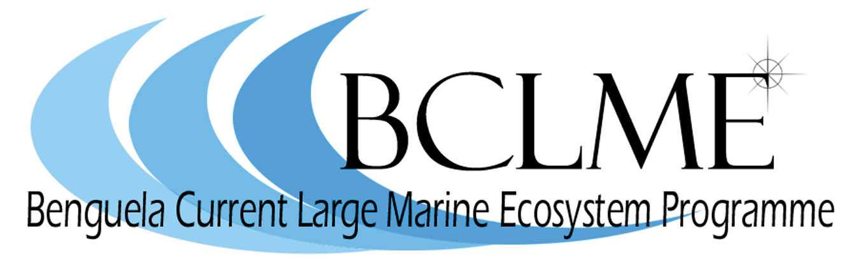

Media Release

The Namibian Minister of Fisheries and Marine Resources, Dr Abraham Iyambo, will deliver the keynote address at a three-day symposium which will be held in Swakopmund from 19 to 21 November. The symposium will focus on the key scientific outcomes and other achievements of two regional marine programmes: the Benguela Environment Fisheries Interaction and Training (BENEFIT) Programme and the Benguela Current Large Marine Ecosystem (BCLME) Programme.

Both BENEFIT and the BCLME Programme will be concluded at the end of 2007. In 2008, major responsibilities of the BCLME Programme will be transferred to the newly established Benguela Current Commission (BCC). At the same time, BENEFIT will be transformed into the Ecosystem Coordinating Committee of the BCC.

The Benguela Current Commission is the first commission in the world to be based on the Large Marine Ecosystem approach to ocean governance. It provides a platform for Angola, Namibia and South Africa to introduce an integrated, multi-sectoral approach to managing the Benguela Current Large Marine Ecosystem.

The Commission is hosted by Namibia and Minister Iyambo is its first chairperson.

The final symposium of the BENEFIT and BCLME programmes, which were developed and implemented by Angola, Namibia and South Africa over the past ten years, will provide participants with an opportunity to celebrate their achievements and highlight the most important transboundary environmental challenges faced by the three countries of the Benguela region.

It will be attended by marine scientists, fisheries managers, economists, representatives of marine industries, non-governmental organisations and academics from the Benguela region. There will also be representation from international institutes and organisations which have participated in the two programmes.

Topics under discussion will include marine scientific research, transboundary management of shared stocks, links between fisheries and the environment, monitoring the state of the ecosystem, marine pollution, the impacts of seabed mining and oil and gas production on the marine environment, as well as socio-economics and governance.

“This occasion gives us an opportunity to reflect on a decade of collaboration in marine science and ecosystem management in the Benguela region,” says Dr Michael O’Toole, chief technical advisor of the BCLME Programme and acting executive secretary of the Benguela Current Commission.

“Several hundred scientists, technicians and administrators in Angola, Namibia and South Africa have been involved in the BENEFIT and BCLME Programmes and many junior scientists have received excellent training through these programmes”.

According to Dr O’Toole, BENEFIT and the BCLME Programme received invaluable support from international partners. The Norwegian research vessel Dr Fridtjof Nansen conducted research surveys in the Benguela region for several years, while Germany deployed several vessels for research and training cruises. Iceland and Japan provided smaller research vessels while France assisted by helping to set up capacity for monitoring the surface waters of the Benguela via satellite imagery.

“This assistance is gratefully acknowledged,” says Dr O’Toole, “as is the financial support provided by the Global Environment Facility and other international funding agencies.”

Members of the media are invited to attend the opening ceremony of the Benguela Symposium which will take place at the Swakopmund Hotel and Entertainment Centre on Sunday 18 November. The ceremony begins at 18h00.

Issued by the BENEFIT Secretariat and the Benguela Current Large Marine Ecosystem Programme
15 November 2007

For further information:

Pavitray Pillay (BENEFIT Secretariat)
Tel: 064 410 1167
Cell: 081 149 0423

Dr Michael O’Toole (BCLME Programme)
061 24 6948
081 1290830

Claire Attwood (Media Consultant: BCLME Programme)
+ 27 21 788-5453 or +27 83 290 7995

