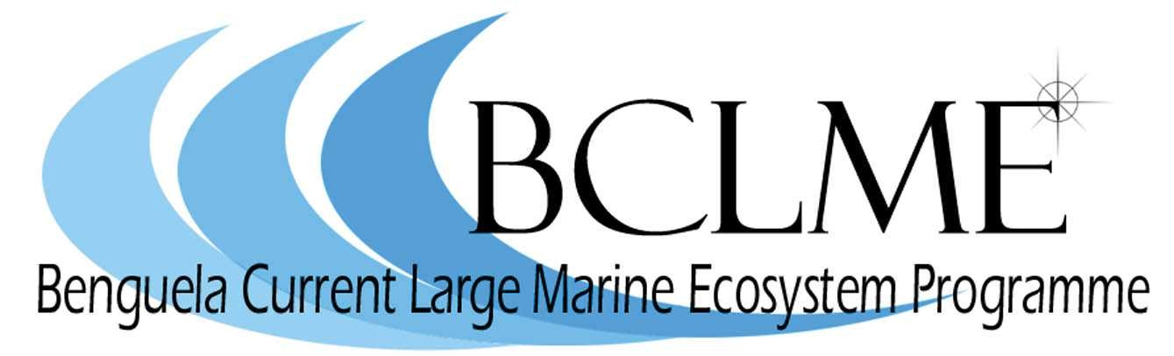
Press Release

New report outlines a blueprint for protecting Southern Africa’s marine ecosystems

WWF and the Benguela Current Large Marine Ecosystem (BCLME) programme today launched a new report that provides a detailed plan for reducing the impacts of fishing on the marine ecosystems of southern Africa.

Traditionally, fisheries have been managed by means of so-called ‘single-species’ techniques, whereby the majority of management protocols were aimed at maintaining the populations of target species at commercially viable levels, with little consideration of the impacts of fishing on other components of the marine ecosystem. This narrow management approach has been held responsible for the current poor state of our global oceans and declining socio-economic returns for those that depend on it.

However, during the last decade a new approach to fisheries management has gained global impetus. This new approach, called the ‘Ecosystem Approach to Fisheries’, refocuses fisheries management on maintaining the overall health of the marine ecosystem that sustains commercially important species. Southern African states committed themselves to implementing this new approach to fisheries management at the World Summit on Sustainable Development (WSSD) which took place in Johannesburg in 2002.

This new report, launched by WWF and the BCLME Programme, is part of a project to assess the feasibility of implementing such an ‘Ecosystem Approach’ to the management of fisheries in the BCLME. The report includes the results of ecological risk assessment workshops conducted on eight South African and Namibian fisheries. These workshops sought to identify and prioritise the main ecological, social and governance risks of each fishery and to develop management responses to remedy these risks.

Some of the main ecological risks that were identified by the workshop participants included:
1. Impacts on top predators such as seabirds, sharks and tunas, through the removal of fish they would normally feed on
2. The impacts of fishing gear on vulnerable and slow breeding species, such as turtles, seabirds and sharks.
3. Impacts of heavy fishing gear on the sensitive sea life on the bottom of the ocean

The report goes on to propose a blueprint of 22 operational objectives that fisheries managers will need to consider if they wish to implement an Ecosystem Approach to Fisheries in southern Africa.

Says Dr Michael O’Toole, chief technical advisor for the BCLME programme, “We believe that this report delivers a very clear and practical plan of how we can go about implementing an Ecosystem Approach to fisheries in Southern Africa.”

Dr Deon Nel, head of the WWF Sanlam Living Waters Partnership, who was involved in facilitating the workshops and compiling the report, adds: “At the outset of this project, many stakeholders were intimidated by the complexity of implementing an Ecosystem Approach. However, through this process we have been successful in breaking down this complex aspiration into a practical plan that prioritizes actions and resources”.

“Having this plan on the table is great achievement. However, we now need to move from planning to implementation,” says Nel.

Implementation might mean changing fisheries regulations to reduce impacts on the ecosystem, creating new governance structures to allow for effective participatory decision making, or initiating new research to allow a better understanding of the ecosystem.

“Importantly, we will need to implement a measurable way of systematically reviewing our progress towards meeting our WSSD goal of implementing an Ecosystem Approach by 2012. Otherwise this will remain just another meaningless commitment, and the health of our oceans, and the wellbeing of those that depend on it, will continue to decline”, emphasised Nel.

For further information contact:

Dr Deon Nel
Manager: WWF Sanlam Living Waters Partnership
021 888 2800
082 891 1038
dnel@wwf.org.za
www.wwf.org.za

Samantha Petersen
WWF Responsible Fisheries Programme Manager
021 425 3440
073 237 8185
spetersen@wwf.org.za
www.wwf.org.za

Dr Michael O’Toole
Chief Technical Advisor: BCLME Programme
+264 61 246 948
otoole.mick@gmail.com
www.bclme.org

Issued by:

Sarah-Leigh Paul
Communications Coordinator: WWF Sanlam Living Waters Partnership
021 888 2820
082 780 6965
spaul@wwf.org.za
www.wwf.org.za

