TENDER

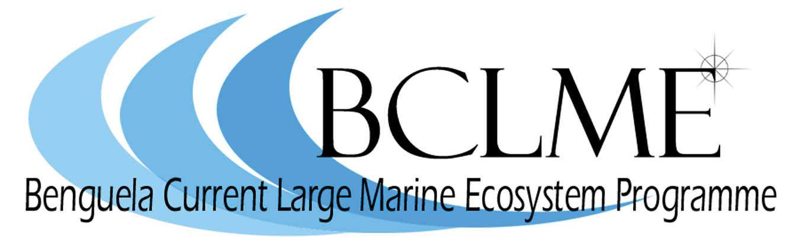

Benguela Current Large Marine Ecosystem (BCLME) Programme is a multi-sectoral regional initiative by Angola, Namibia and South Africa whose objective is to facilitate the integrated management, sustainable development and protection of this unique eastern boundary upwelling ecosystem. It is funded by the Global Environment Facility (GEF) under its International Water Portfolio and is implemented by the United Nations Development Programme (UNDP) with the United Nations Office for Project Services (UNOPS) as executing agency. The three member countries provide further financial and in-kind contributions.

As part of the process of implementing various BCLME activities, the Programme Coordination Unit (PCU) wishes to announce that the following projects are being put out to tender:

BCLME/EEWS/05/01 Development of and making operational, a viable and integrative Environmental Early Warning System (EEWS) for the BCLME.

BCLME/SEIS/05/01 Development of and making operational, a viable and integrative State of the Ecosystem Information System for the BCLME.

Contractors who wish to tender for any of the above projects should note that criteria for selection should include where possible: a) the use of nationals or permanent residents of Angola, Namibia and South Africa b) close liaison with government institutions, local universities and stakeholders in the three countries and c) regional capacity building and training as an integral part of the project implementation.

Interested parties wishing to tender for any of the above projects can find the Request for Proposal and detailed Terms of References at www.bclme.org or can request these directly from the address below. Two hard copies of formal submissions of tenders, accompanied by an electronic version (saved in Rich Text Format), should be sent to:

Dr Mick O'Toole
BCLME Programme Coordination Unit (PCU)
Hidas Centre, 1st Floor, Sam Nujoma and Nelson Mandela Ave
Klein Windhoek, Namibia
P.O. Box 40728, Ausspannplatz, Namibia
Tel: 264 61 24 6948
Fax: 264 61 24 6803
Email: pcu@bclmenamibia.org

An electronic version of the proposal should be sent to Ms. Margaret Chi, UNOPS, Margaretc@unops.org and to Ms Lesley Staegemann, (EVAC), bclmeevg@deat.gov.za

The closing date for receiving the submissions is 17h00 on 3rd October 2005.

