Module IV
Harmful raphidophytes (3 hours)

Contents
1.1. Suggested reading
1.2. Some basic features of raphidophytes
1.3. Taxonomy of raphidophytes
1.4. Harmful species
1.5. References
1.6. Glossary
2. Exercises
References in bold are either from the textbook (Graham & Wilcox 2000) or available as pdf files on the course CD.

1.1. Suggested reading
Present document, textbook, and the following papers:

Graham & Wilcox 2000: Chapter 13, p.269 (Ochrophytes II) – 272 (Gonyostomum).
Imai, I., Yamaguchi, M. & Watanabe, M. 1998. Ecophysiology, life cycle, and bloom dynamics of Chattonella in the Seto Inland Sea, Japan. - In: Anderson, D.M., Cembella, A.D. & Hallegraeff, G.M. (eds), Physiological Ecology of Harmful Algal Blooms, NATO-ASI series 41, Springer, Berlin, pp.93-112, (see Books, pdf file NATO ASI).
.Smayda, T.J. 1998. Ecophysiology and bloom dynamics of Heterosigma akashiwo (Raphi-dophyceae). - In: Anderson, D.M., Cembella, A.D. & Hallegraeff, G.M. (eds), Physiological Ecology of Harmful Algal Blooms, NATO-ASI series 41, Springer, Berlin, pp. 113-131, (see Books, pdf file NATO ASI).
.

1.2. Some basic features of raphidophytes

Morphology
Raphidophyte cells possess two sub-equal, heterodynamic flagella arising from a more or less pronounced flagellar groove (Olisthodiscus, Heterosigma). The anterior flagellum has two rows of fine tripartite hairs, which are visible only by electron microscopy, while the posterior (trailing) flagellum is smooth and lies close to the surface of the cell (see Figure 1).
The cells are naked, dorso-ventrally flattened and contain numerous ejectosomes (Heterosigma), trichocysts and mucocysts (Chattonella, Fibrocapsa) that readily discharge, thereby rendering these species difficult subjects for microscopic studies.
The cells contain numerous golden-brown chloroplasts in the peripheral cytoplasm (termed ectoplasm), which upon cell disintegration gives a characteristic ‘raspberry-like’ appearance to the cell remains. The main accessory pigment in marine raphidophytes is fucoxanthin.
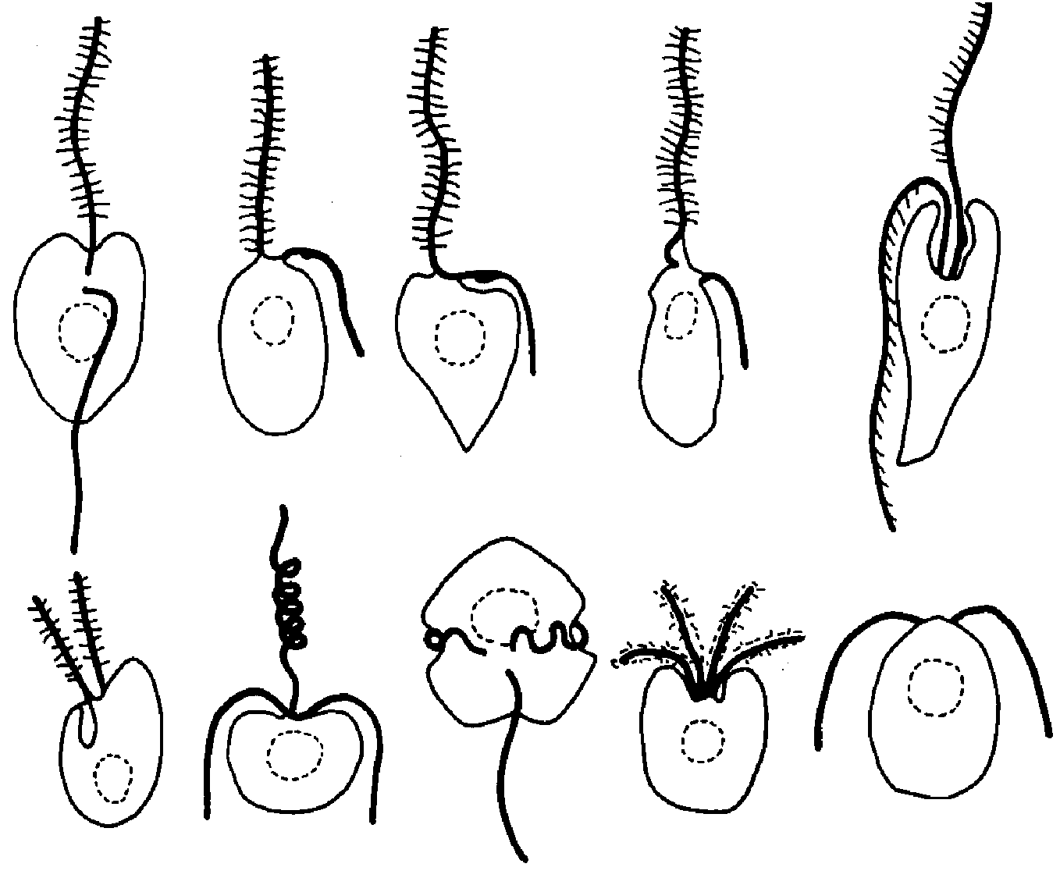
Fig.1. Summary of flagellar organisation in unicellular algae found in marine phytoplankton: (1) Raphidophyte; (2) Xantophyte; (3) Chrysophyte; (4) Eustigmatophyte; (5) Euglenophyte; (6) Cryptophyte; (7) Haptophyte; (8) Dinoflagellate; (9) Prasinophyte; (10) Chlorophyte.
1 2 3 4 5
6 7 8 9 10

Life cycle
Asexual reproduction is by binary division. A diplontic life cycle (Fig. 2) has been described for Chattonella, with cyst formation occurring after meiosis in vegetative cells. The hemispherical cysts have a simple pore on top and are commonly attached to diatom frustules in surface sediments. At present there is little information about how meiosis and diploidization occur. For Heterosigma benthic resting cells consisting of agglutinated masses of non-motile brown cells of variable size and shape have also been described.

1.3. Taxonomy of raphidophytes
Considerable confusion exists regarding the taxonomy of the group and various members have often mistakenly been assigned to other algal classes such as cryptomonads, chrysophytes, dinoflagellates and euglenoids. A misleading common name for this group of flagellates is “chloromonads”; however, marine species are golden-brown in colour and not green as the name suggests.
Raphidophyte flagellates are extremely fragile and generally are best studied in unpreserved water samples. Cells range from 6-15 µm length (e.g. Heterosigma, easily missed by plankton nets) to 70-130 µm length (Chattonella), they perform active diurnal migrations and can cause orange-brown water discolouration. For identification of raphidophyte species, see Throndsen (1997) and Hallegraeff & Hara (2004). The phylogenetic relationship of raphidophytes has been studied by Potter et al. (1997).
Five genera of marine raphidophytes are recognized by most authors, e.g. Hara & Chihara (1985, 1987) and Throndsen (1997), while Loeblich & Fine (1977) recognized only Chattonella. Table 1 summarizes the most important features separating the 5 genera.
The taxonomy of H. akashiwo has been confused in the past. Several studies of O. luteus, e.g. Leadbeater (1969), Tomas (1978), and Gibbs et al. (1980), are now recognized as studies of H. akashiwo.
Taylor (1992) claimed that the correct name of H. akashiwo is H. carterae (Hulburt) Taylor, but Throndsen (1996) clarified the nomenclatural problems clinging to this species and concluded that the description of H. akashiwo by Hara & Chihara 1987 was the first to fulfil the requirements of the ICBN, and therefore is the correct name for this species.

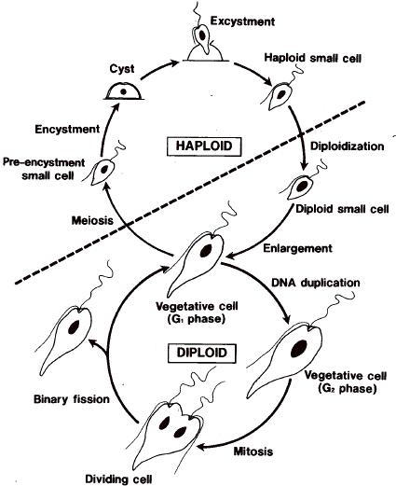
Fig. 2. Diplontic life cycle of Chattonella (after Imai et al. 1998).

Table 1. Some important features of the marine raphydophycean genera (modified from Horiguchi 1996).
 | Chattonella | Fibrocapsa | Haramonas | Heterosigma | Olisthodiscus
No. of species | 7 | 1 | 2 | 1 | 3
Cell shape and size | Globular-oblong, some species with a posterior tail, some slightly flattened | Ellipsoidal, slightly flattened, 20-30 µm long | Club-shaped, 24-39 µm long | Irregular ovoid (sack-of-potato-shaped), slightly flattened, 8-25 µm long | Oval, strongly compressed, 15-25 µm long
Flagella | Inserted in a apical gullet | Inserted in a apical gullet | Apical insertion | Sub-equal, inserted in a subapical-lateral oblique groove | Subapical, inserted in ventral groove
Chloroplasts | Many, with a radial arrangement | Many, densely packed in the cell, with pyrenoids | 10-20, arranged peripherally, overlapping | 10-30 in the cell periphery | 5-13 in the cell periphery, disc-shaped with pyrenoids
Mucocysts | Present/absent | Rod-shaped, posterior | Present | Present | Absent
Other features |  |  | With a tubular invagination posteriorly |  | O. luteus is a benthic species

1.4. Harmful species
Raphidophytes can pose serious threats to finfish aquaculture. In the 1970s and 1980s much attention focused on species of the genus Chattonella as the cause of mortality of cultured yellowtail and red sea bream in Japanese inland seas but in the 1990s attention has shifted to Heterosigma as the cause of fish kills in New Zealand, Chile and British Columbia. Tropical fish kills have been associated with Chattonella blooms in India, and blooms have been observed also in South America, e.g. Odebrecht & Abreu (1995), Proença & Fernandes (2004). The bloom dynamics of H. akashiwo and Chattonella have been reviewed by Smayda (1998) and Imai et al. (1998), respectively.
The killing mechanism of raphidophyte blooms is still poorly understood. Both physical clogging of fish gills by mucus excretion as well as gill damage by haemolytic substances may be involved. Some but not all species and strains may contain brevetoxin-like neurotoxins (Khan et al. 1996a, 1996b, 1997), but more recent studies have questioned these results (Marshall et al. 2003). Free fatty acid production, notably of eicosapentaenoic acid (17-27% of total fatty acids), may also play a role in fish mortalities caused by raphidophyte blooms. New evidence is now pointing towards the production by raphidophyte algae of high concentrations of superoxide and hydroxyl radicals as a mechanism that enhances the toxicity of fatty acids and neurotoxins to fish (see Landsberg 2002, Hallegraeff & Hara 2004 and references therein, Haque & Onoue 2002, Marshall et al. 2002, 2005, Twiner et al. 2004).

1.5. References
Gibbs, S.P., Chu, L.L. & Magnussen, C.1980. Evidence that Olisthodicus luteus is a member of the Chrysophyceae. - Phycologia 19: 173-177.
Hallegraeff, G.M. & Hara, Y. 2004. Taxonomy of harmful marine raphidophytes. - In: Hallegraeff, G.M., Anderson, D.M., Cembella, A.D. (eds), Manual on harmful marine microalgae, Monographs on oceanographic methodology 11, Unesco, Paris, pp. 511-522.
Haque, S.M. & Onoue, Y. 2002. Variation in Toxin Compositions of Two Harmful Raphido-phytes, Chattonella antiqua and Chattonella marina, at Different Salinities. - Environ Toxicol 17: 113–118.
Hara, Y. & Chihara, M. 1985. Ultrastructure and taxonomy of Fibrocapsa japonica (Class Raphidophyceae). - Arch. Protistenk. 130: 133-141.
Hara, Y. & Chihara, M. 1987. Morphology, ultrastructure and taxonomy of the raphydop-hycean alga Heterosigma akashiwo, - Bot. Mag. Tokyo 100: 151-163.

Horiguchi, T. 1996. Haramonas dimorpha gen et sp. nov. (Raphydophycaea), a new marine raphydophyte from Australian mangrove. - Phycological Research 44: 143-150.
Imai, I., Yamaguchi, M, Watanabe, M. 1998. Ecophysiology, life cycle, and bloom dynamics of Chattonella in the Seto Inland Sea, Japan. - In: Anderson, D.M., Cembella, A.D.& Hallegraeff, G.M. (eds), Physiological Ecology of Harmful Algal Blooms, NATO-ASI series 41, Springer, Berlin, pp.93-112.
Khan, S., O. Arawaka & Y. Onoue. 1996a. Neurotoxin production by a chloromonad Fibrocapsa japonica (Raphidophyceae). - Journal of the World Aquaculture Society. 27: 254-263.
Khan, S., O. Arawaka & Y. Onoue. 1996b. A toxicological study of the marine phytoflagellate, Chattonella antiqua (Raphidophyceae). - Phycologia 35: 239-244.
Khan, S., O. Arawaka & Y. Onoue. 1997. Neurotoxins in a toxic red tide of Heterosigma akashiwo (Raphidophyceae) in Kagoshima Bay, Japan. - Aquaculture Research 28: 9-14.
Landsberg, J. H. 2002. The effects of harmful algal blooms on aquatic organisms. – Reviews in Fisheries Science 102: 113-390.
Leadbeater, B.S.C. 1969. A fine structural study of Olisthodiscus luteus Carter. – Br. Phycol. J. 4: 3-17.
Loeblich III, A. R. & Fine, K. E. 1977. Marine chloroplast: More widely distributed in neritic environments than previously thought. - Pro. Biol. Soc. Wash. 90: 388-399.
Odebrecht, C. & P.C. Abreu. 1995. Raphidophycean in southern Brazil. - IOC of UNESCO Harmful Algae News 12/13: 4.RESEARCH ARTICLE
Marshall, J.A., de Salas, M., Oda, T. & Hallegraeff, G.M. 2005. Superoxide production by marine microalgae. - Marine Biology 147: 533–540.
Marshall, J.A, Nichols, P.D. & Hallegraeff, G.M. 2002. Chemotaxonomic survey of sterols and fatty acids in six marine raphidophyte algae. - Journal of Applied Phycology 14: 255–265.
Marshall, J.A., P. D. Nichols, B. Hamilton, R.J. Lewis & G.M. Hallegraeff. 2003. Ichtyotoxicity of Chattonella marina (Raphidophyceae) to damselfish (Acanthochromis polycanthus): the synergistic role of reactive oxygen species and free fatty acids. - Harmful Algae 2, 273-281.
Potter, D., G.W. Saunders & R.A. Andersen. 1997. Phylogenetic relationships of the Raphidophyceae and Xanthophyceae as inferred from nucleotide sequences of the 18S ribosomal RNA gene. - American Journal of Botany 84(7), 966-972.
Proença, L.A.O., Fernandez, L.F. 2004. Introdução de microalgas no ambiente marinho: impactos negativos e fatores controladores. - In: Silva, J.S.V. & Souza, R.C.C.L. (org.), Água de Lastro e Bioinvasão, Chapter 7: 77-97. Rio de Janeiro, Ed. Interciência.
Smayda, T.J. 1998. Ecophysiology and bloom dynamics of Heterosigma akashiwo (Raphidophyceae). - In: Anderson, D.M., Cembella, A.D. & Hallegraeff, G.M. (eds), Physiological Ecology of Harmful Algal Blooms, NATO-ASI series 41, Springer, Berlin, pp. 113-131.
Taylor, F.J.R. 1992. The taxonomy of harmful marine phytoplankton. - Giornale Botanio Italiano 126: 209-219.
Throndsen J. 1996. Note on the taxonomy of Heterosigma akashiwo (Raphidophyceae). - Phycologia 35: 367.
Throndsen J. 1997. The plantonic marine flagellates. - In: Tomas, C. T. (ed.), Identifying Marine Phytoplankton, Academic Press, USA, pp. 591-729.
Tomas, C.R. 1978. Olisthodiscus luteus (Chrysophyceae). II. Formation and survival of a benthic stage. - J. Phycol. 14: 314-319.
Twiner, M.J., S. J. Dixon & C.G. Trick. 2004. Extracellular organics from specific cultures of Heterosigma akashiwo (Raphidophyceae) irreversibly alter respiratory activity in mammalian cells. - Harmful Algae 3, 173-182.

1.6. Glossary

English | Español | Português
Bullet shaped | Forma de bala | Em forma de bala
Diplont | Diplonte | Diplonte
Diplohaplont | Diplohaplonte | Diplohaplonte
Ejectosome | Ejectosoma | Ejectossoma
Extrusome | Extrusoma | Extrussoma
Eyespot | Estigma | Estigma
Flagelar groove | Surco flagelar | Sulco do flagelo
Flimmer | Mastigonema | Mastigonema’
Groove | Surco | Sulco, reentrância
Gullet | Invaginación | Invaginação
Hair | Pelo | Pelos rígidos, mastigonemas
Haplont | Haplonte | Haplonte
Heterokont | Heteroconta | Heteroconto
Mucocyst | Cuerpos muciferos-mucocistos | Mucocisto
Naked | Sin pared, desnudo | Desnudo, sem parede.
Pyrenoid | Pirenoide | Pirenóide
Pyriform | Forma de pera | Piriforme, forma de pera
Rod-shaped | Forma de bastón | Forma de bastonete
Smooth flagellum | Flagelo liso | Flagelo liso
Statospore | Estatosporo | Estatosporo, cisto endógeno
Tail | Apendice caudal | Cauda
Thylakoid | Tilacoide | Tilacóide
Trailing flagellum | Flagelo posterior, arratrado. | Flagelo posterior, arrastado
Tripartite hairs | Mastigonemas tripartitos | Mastigonemas tripartidos
Trichocyst | Tricocistos | Tricocisto
Vacuolated ectoplasm | Ectoplasma vacuolizado | Ectoplasma vacuolado
Verrucose protrusions | Protrusiones verrucosas | Saliências rugosas

