Module III
Section 4, Gonyaulacales (8 hours)

Contents

4.1. Suggested reading
4.2. The potentially harmful genera
4.3. Genus Alexandrium
Taxonomy
Identification of species of Alexandrium
Harmful species
4.4. Coolia
4.5. Gambierdiscus
4.6. Ostreopsis
4.7. Pyrodinium bahamense var. compressum
4.8. References

References in bold are available as pdf files on the course CD.

4.1 Suggested Reading

Present document and the following papers:

Balech, E. 1989. Redescription of Alexandrium minutum (Dinophyceae) type species of the genus Alexandrium. - Phycologia 28: 206-211.
Taylor, F.J.R. & Fukuyo, Y. 1998. The neurotoxigenic dinoflagellate genus Alexandrium Halim: general introduction. - In: Anderson, D.M., Cembella, A.D. & Halle-graeff, G.M. (eds), Physiological ecology of harmful algal blooms, NATO ASI series, Series G, Ecological sciences, vol. 41, Springer-Verlag, Berlin, pp.3-11, (see Books, pdf file NATO ASI)..
Tindall, D.R. & Morton, S.L. 1998. Community dynamics and physiology of epiphytic/ benthic dinoflagellates associated with ciguatera. – In: Anderson, D.M., Cembella, A.D. & Hallegraeff, G.M. (eds.), Physiological ecology of harmful algal blooms, NATO ASI series, Series G, Ecological sciences, vol. 41, Springer-Verlag, Berlin, pp. 291-313, (see Books, pdf file NATO ASI).
.

4.2. The potentially harmful genera
This order is characterized by a strongly asymmetrical organization of the thecal plates. The apical pore complex is also asymmetrical and is never connected to the 1’ by a canal plate as is the case in the Peridiniales. The typical plate formula is 4’, 6’’, 6c, 5s, 5’’’, 2’’’’ according to Fensome et al. (1993). Variations in this plate formula – and also different interpretations - do occur, and are indicated below where appropriate. For Alexandrium, see Fig. 1.

The potentially toxic species belong mainly in the genera Alexandrium, Coolia, Gambier-discus, Ostreopsis, and Pyrodinium, see below. It should be noted, however, that also the common and widespread species Lingulodinium polyedrum (Stein) Dodge 1989 and Protoceratium reticulatum (Claparède et Lachmann) Bütschli 1885 may produce toxins (see also Module VII).

4.3. Genus Alexandrium

Taxonomy
The genus Alexandrium was created by Halim (1960) with A. minutum as the type species. However, many details pertaining to the plate pattern of the new species, and now regarded important both for the delineation of the genus and for the identification of species of Alexandrium, were not noted by Halim. This situation has created considerable taxonomic confusion in the past, and species now assigned to Alexandrium have previously been referred to Gonyaulax Diesing 1866, Goniodoma Stein 1883, Gessnerium Halim 1967, or Protogonyaulax Taylor 1979. Taxonomic reviews of Alexandrium may be found in Balech (1989) or Taylor & Fukuyo (1998), and in the monographic work of Balech (1995).
The genus is characterized by the following plate formula: Po, 4', 6'', 6c, 10s, 5''', 2'''' (Fig. 1). The apical pore plate (Po) has a comma-shaped hole covered by a tiny plate, and the Po plate may have an anterior attachment pore and a number of additional marginal pores; these features together form the apical pore complex (APC). Alexandrium may be distinguished from the common genus Gonyaulax by the presence of only three apical plates and two anterior intercalary plates in the latter; for further comparisons to related genera, see Fensome et al. (1993) and Steidinger (1997).

Identification of species of Alexandrium
Most species of Alexandrium have been described from natural material, and several of these are differentiated by very minor deviations in plate morphology. Only a few species, e.g. A. tamarense, have been studied in culture, and future culture studies on morphological variation may reveal that the genus is over-classified and reduce the number of species. Recent biochemical and molecular studies do not at least in some cases support the morpho-species concept particularly within the A. tamarense-fundyense-catenella complex (Scholin 1998, Sako 1999, Higman et al. 2001), and A. minutum Lilly et al. (2005). However, the morphological species concept is still useful and important information on distribution etc. may be lost if this is not applied in distinguishing species.
In addition to the general characters such as size, shape, and chain formation, the morphology of particularly the 1', 6'’, Po, APC, and the s.p. plates are important for identification, see Fig 1. The features distinguishing the species can usually be observed in the light microscope, but several features are very fine and difficult to discern, and require careful observation. It should also be noted that the chains in colony-forming species often disintegrate in preserved samples. In most species, the 1' is connected to the APC either directly or indirectly by a filiform prolongation, and it usually has a ventral pore. In some species, the 1' and the APC are clearly disconnected.

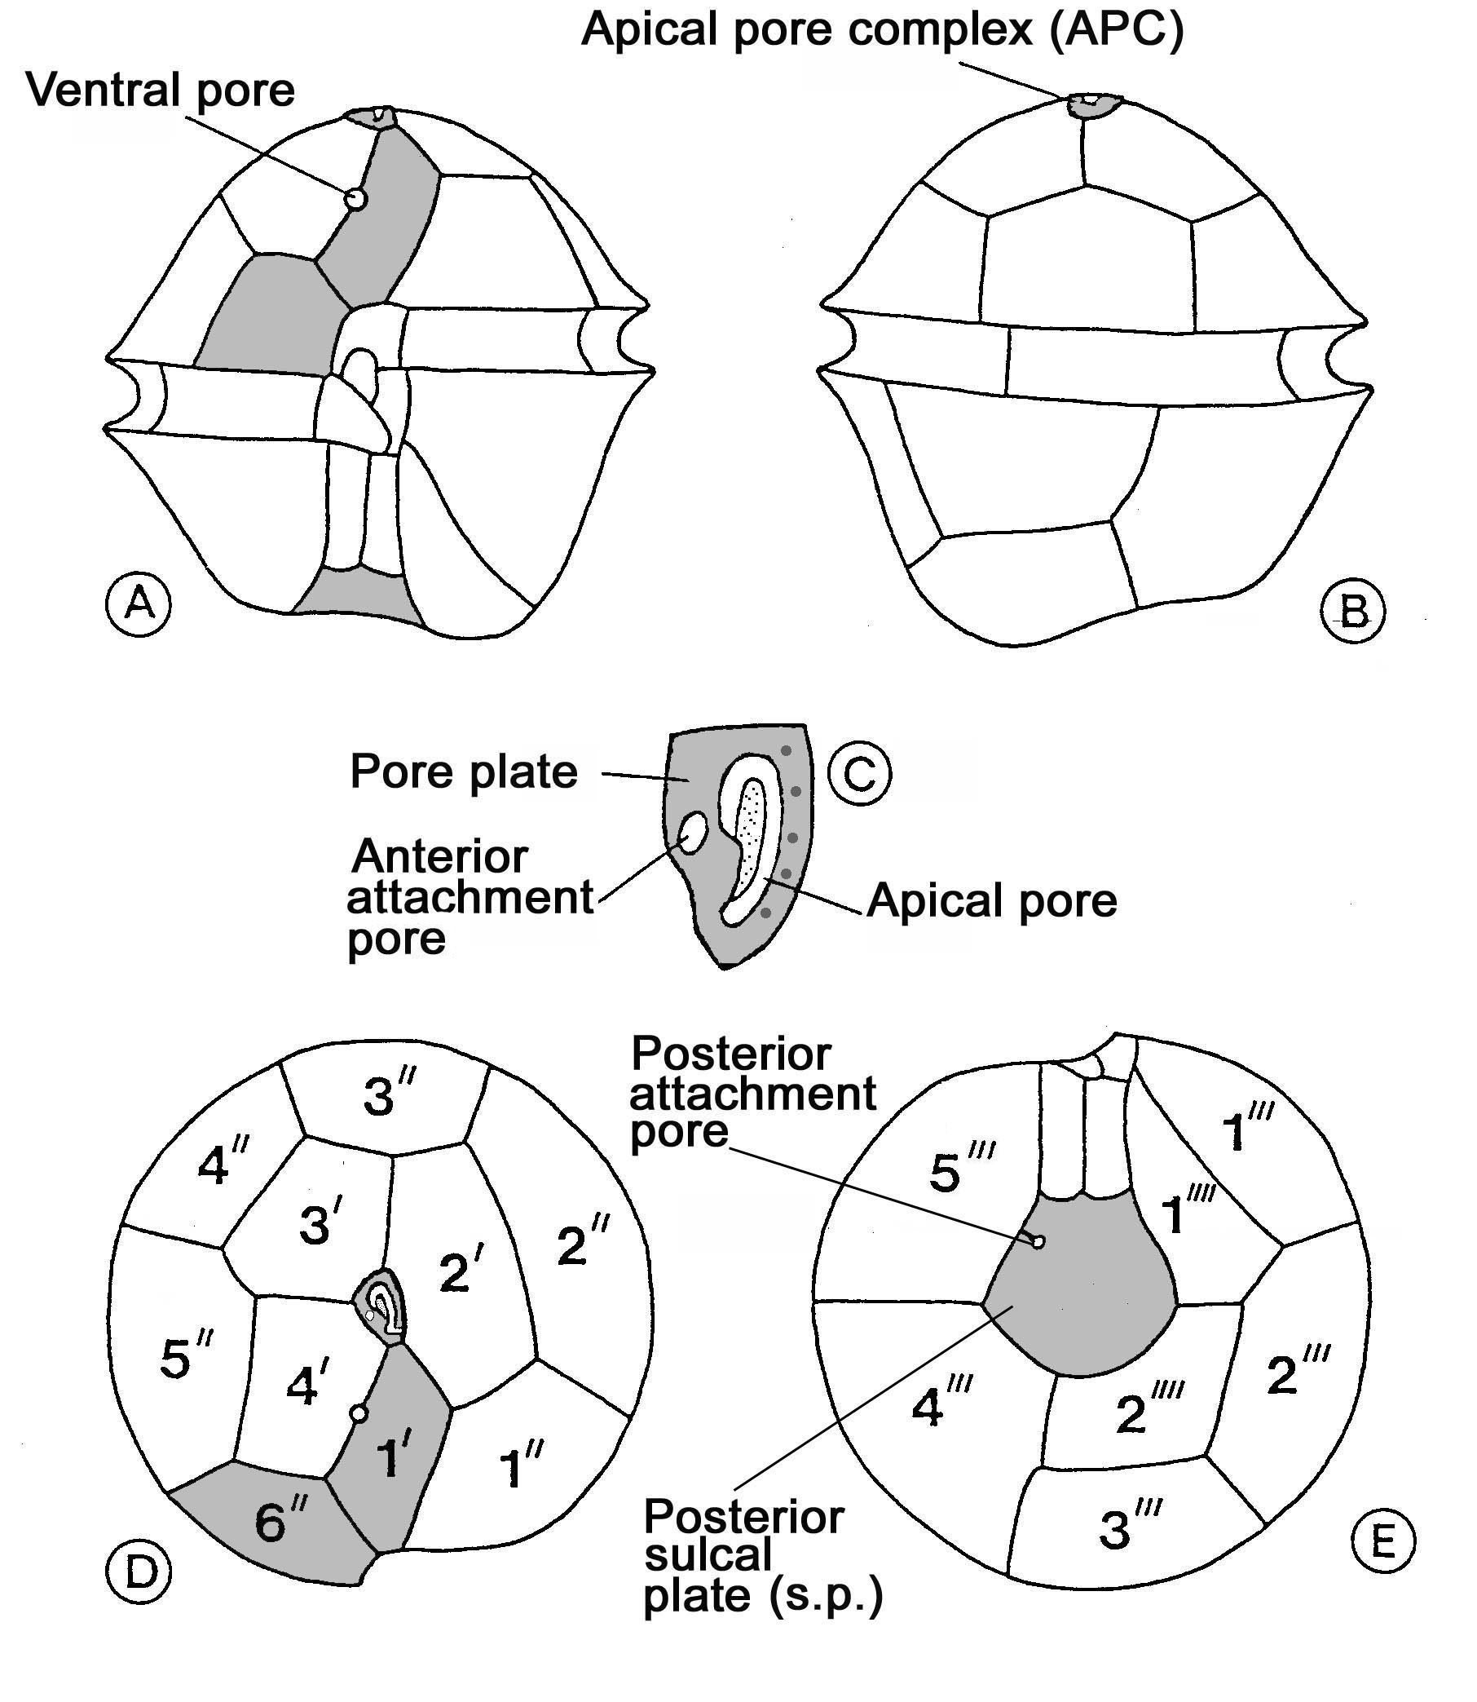
Figure 1. The thecal plate arran-gement of Alexandrium (redrawn from Balech 1995).

A: ventral view,
B: dorsal view,
C: apical pore complex (APC),
D: apical view,
E: antapical view.

Based on morphological features, Balech (1995) recognized 29 species of Alexandrium, assigned to two subgenera, and a number of species groups as follows:
Subgenus Alexandrium (syn. Protogonyaulax Taylor): The 1'-plate is connected to the APC. The subgenus comprises the following species groups:
- the catenella group, includes 2 species (A. catenella, A. compressum), chain-forming with anterior-posteriorly compressed cells, 1' lacks a ventral pore,
- the fraterculus group, includes 3-4 species (A. affine, A. cohorticula, A.fraterculus, A. tamiyavanischii), chain-forming species with a ventral pore,
- the kutnerae group, includes 2 species (A. kutnerae, A. leei), the ventral pore is located inside the 1' plate,
- the minutum group, includes 4 species (A. andersonii, A. angustitabulatum, A. lusitanicum, A. minutum), some of which may be synonymous, small species (usually < 30 µm) characterized by a very narrow 6'’ plate and a short s.p. plate,
- the ostenfeldii group, includes 2 probably synonymous species (A. ostenfeldii, A. peruvianum), characterized by a narrow 1' plate with a large ventral pore,
- tamarense group, includes 4 species (A. acatenella, A. fundyense, A. tamarense, A. tropicale), this group is difficult to define morphologically, and the shape of the s.p. plate (with two ventrally directed, anterior prolongations) appears to be the only common feature.
Subgenus Gessnerium: The 1’-plate is not connected to the APC. The subgenus comprises 10 species: Alexandrium balechii, A. concavum, A. foedum, A. hiranoi, A. insuetum, A. margalefii, A. monilatum, A. pseudogonyaulax, A. satoanum, A. taylori.
In addition to the species included in Balech (1995), 4 more species of Alexandrium have been described: A. camurascutulum Mackenzie et Todd (Mackenzie & Todd 2002), A. gaarderae Nguyen-Ngoc et Larsen, A. globosum Nguyen-Ngoc et Larsen (Nguyen-Ngoc & Larsen 2004) and A. tamutum Montresor, Beran et John (Montresor et al., 2004).
For species identification the reader is referred to Balech (1995), Nguyen & Larsen (2004), and Taylor et al. (2004), and particularly for the South American region Balech (2002).

Harmful species
Several species of Alexandrium may produce paralytic shellfish poisons, see e.g. Taylor et al. (2004). Some species seem to produce also other types of toxins with haemolytic activity (Simonsen et al. 1995) and which may cause fish kills (Ogata & Kodama 1986). A. ostenfeldii may produce spirolide shellfish toxins, see Module VII.
Some Alexandrium species may produce sexual resting cysts. These cysts may be even more toxic than the vegetative stage (Dale et al. 1978), and play an important role in bloom dynamics (see Anderson et al. 2004, Matsuoka & Fukuyo 2004, and references therein).

4.4. Coolia
This genus comprises benthic 3 species: C. areolata Ten-Hage, Turquet, Quod et Couté 2000, C. monotis Meunier 1919, and C. tropicalis Faust 1995 with the following plate formula: Po, 3(4)’, 7 (6)’’, 6c, ≥6s, 5’’’, 1p, 2’’’’. Faust (1992) described C. monotis by SEM.
C. monotis is an epiphytic toxin producing species preferring moderately exposed habitats with limited freshwater inflow, widely distributed from temperate to tropical waters (Tindall & Morton 1998, Rhodes & Thomas 1997). The toxin produced – cooliatoxin - is toxic to larvae of Artemia and Haliotis (Holmes et al. 1995) and contributes to ciguatera.

4.5. Gambierdiscus
Adachi & Fukuyo (1979) described Gambierdiscus with the following plate formula: Po, 3’, 7’’, 6c, 8s, 6’’’, 1p, 1’’’’, but subsequent interpretations indicate: Po, 4’, 6’’, 6c, 8s, 5’’’, 2’’’’ (e.g. Steidinger 1997), or Po, 3’, 7’’, 6c, 8s, 5’’’, 1p, 2’’’’ (e.g. Chinain et al. 1999). Thus, the largest plate of the hypotheca which is used in differentiation of species is interpreted as 2’’’’ by some authors and as 1p by others.
The genus comprises 6 species: G. australes Faust et Chinain 1999, G. belizeanus Faust 1995, G. pacificus Chinain et Faust 1999, G. polynesiensis Chinain et Faust 1999, G. toxicus Adachi et Fukuyo 1979, and G. yasumotoi Holmes 1998. The latter species is globular in shape, while the others are anterio-posteriorly compressed and differentiated mainly by the size and shape of the Po and 1p (2’’’’) plates. Chinain et al. (1999) discussed the differences between the 6 species of Gambierdiscus.
G. toxicus is generally regarded an epiphytic species, but Nakahara et al. (1996) found in studies from Tahiti that it rather moves around the thalli of macroalgae, particularly species of the red algae Jania and Amphiora, and only attach to the thallus upon disturbances e.g. strong water movements which might wash the cells away. According to Grzebyk et al. (1994) and Tindall & Morton (1998), G. toxicus may occur in a wide variety of habitats including exposed coral reefs, but is often most abundant in more protected habitats.
G. toxicus is the main cause of ciguatera (fish poisoning: ciguatoxins and maitotoxins), and is widely distributed in subtropical and tropical areas.

4.6. Ostreopsis
Species belonging in this genus have strongly antero-posteriorly compressed cells, which are more or less pear-shaped in apical view; thus what appears as the cell length is the dorso-ventral width. The plate formula is the same as in Coolia (Po, 3(4)’, 7 (6)’’, 6c, ≥6s, 5’’’, 1p, 2’’’’) according to Steidinger (1997), but different interpretations occur. As in Coolia, a ventral pore has been found in the cingulum (Faust et al. 1996).
The genus currently comprises 9 species, which are differentiated mainly by cell shape and size, and features relating to the Po, 1’, and 1p plates, see Fukuyo (1981), Faust et al. (1996), and Faust (1999) for discussion of the differences between the 9 species of Ostreopsis. It should be noted that Faust et al. (1996) confused O. siamensis and O. lenticularis indicating that O. siamensis Schmidt 1902 (l.c. Plate 21, Fig. 4) has two types of valve pores, and O. lenticularis only one type of pores, but the original description of O. lenticularis (Fukuyo 1981) clearly indicates that this species has 2 types of pores, see also Nguyen et al. (2004).
Ostreopsis species also contribute to ciguatera in tropical and subtropical regions; they produce toxins which may cause clupeotoxicity in fish. In the Southwest Atlantic, O. ovata was associated with large scale sea urchin mortality.

4.7. Pyrodinium bahamense var. compressum
Pyrodinium bahamense var.compressum (Pbc) has caused major public health and economic problems in the South East Asian region for more than 2 decades (Azanza & Taylor 2001). This thecate dinoflagellate has probably existed since the Eocene (McMinn 1989), and fossil cysts of the species have been recorded from many geographical locations. In contrast, modern, extant cysts of P. bahamense seem to have a more limited distribution, mainly in South East Asia, the Caribbean and in Western Europe (Ferreira & Dale 1997). Various aspects of the biology of P. bahamense var. compressum are described in Hallegraeff & Maclean (1989) and Usup & Azanza (1998).

4.8 References

Adachi, R. & Fukuyo, Y. 1979. The thecal structure of the marine toxic dinoflagellate Gambierdiscus toxicus gen. et sp. nov. collected in a ciguatera-endemic area. – Bull. Jap. Soc. Sci. Fish. 45: 67-71.
Anderson, D.M., Fukuyo, Y. & Matsuoka, K. 2004. Cyst methodologies. - In: Hallegraeff, G.M., Anderson, D.M.,Cembella, A.D. (eds). Manual on harmful marine microalgae, Monographs onoceanographic methodology 11, Unesco, Paris, pp. 165-190.
Azanza, RV. and Taylor, F.J.R. 2001. Are Pyrodinium blooms in Southeast Asian recurring and spreading? A view at the end of the millennium. - AMBIO: A Journal of the Human Environment 30(6):356-364.
Balech, E. 1989. Redescription of Alexandrium minutum (Dinophyceae) type species of the genus Alexandrium. - Phycologia 28:206-211.
Balech, E. 1995. The genus Alexandrium Halim (Dinoflagellata). - Sherkin Island Marine Station, 151 pp.
Balech, E. 2002. Dinoflagelados tecados tóxicos Del Cono Sur Americano. - In: Sar, E. A ., M. E. Ferrario & B. Reguera (eds.), Floraciones Algales Nocivas en el Cono Sur Americano. Instituto Español de Oceanografia, pp. 125-144.
Chinain, M., Faust, M.A. & Pauillac, S. 1999. Morphology and molecular analyses of three toxic species of Gambierdiscus (Dinophyceae): G. pacificus sp. nov., G. australes sp. nov., and G. polynesiensis sp. nov. – J. Phycol. 35: 1282-1296.
Dale, B., Yentsch, C.M. & Hurst, J.W. 1978. Toxicity in resting cysts of the red-tide dinoflagellate Gonyaulax excavata from deeper water coastal sediments. - Science 201: 1223-1225.
Faust, M.A. 1992. Observations on the morphology and sexual reproduction of Coolia mono-tis (Dinophyceae). – J. Phycol. 28: 94-104.
Faust, M.A. 1999. Three new Ostreopsis species (Dinophyceae). O. marinus sp. nov., O. belizeanus sp. nov., and O. caribbeanus sp. nov. – Phycologia 38: 92-99.
Faust, M.A., Morton, S.L. & Quod, J.P. 1996. Further SEM studies of marine dinoflagellates: the genus Ostreopsis (Dinophyceae). – J. Phycol. 32: 1053-1065.
Fensome, R.A., Taylor, F.J.R., Norris, G., Sarjeant, W.A.S., Wharton, D.I. & Williams, G.I. 1993. Micropaleontology. - Special Publication Number 7, 351 pp.
Ferreira, A.A. & Dale, B. 1997. Distribution of cysts from toxic or potentially toxicdinoflagellates along the Portuguese Coast. - Abstract, VIIIth International Conference on Harmful Algae, Vigo, Spain.
Fukuyo, Y. 1981. Taxonomical study on benthic dinoflagellates collected in coral reefs. - Bulletin of the Japanese Society of Scientific Fisheries 47: 967-978.
Grzebyk, D., Berland, B., Thomassin, B.A., Bosi, C. & Arnoux, A. 1994. Ecology of ciguateric dinoflagellates in the coral reef complex of Mayotte Island (S.W. Indian Ocean). – J. Exp. Mar. Biol. Ecol. 178: 51-66.
Halim, Y. 1960. Alexandrium minutum gen. et sp. nov. dinoflagelle provocant des eaux rouges. - Vie Milieu 11: 102-105.
Hallegraeff, G.M. & Maclean, J.L. (eds). 1989. Biology, epidemiology and management of Pyrodinium red tides. – International Centre for Living Aquatic Resources Mana-gement, Manila, Conf.Proc. 21, 286 pp.
Higman, W.A., Stone, D.M. & Lewis, J.M. 2001. Sequence comparisons of toxic and non-toxic Alexandrium tamarense (Dinophyceae) isolates from UK waters. – Phycologia 40: 256-262.
Holmes M.J., Lewis R.J., Jones A. & Hoy A.W. 1995. Cooliatoxin, the first toxin from Coolia monotis (Dinophyceae). - Nat. Toxins 3: 355-362.
Lilly, E.L., Halanych, K.M. & Anderson, D.M. 2005. Phylogeny, biogeography, and species boundaries within the Alexandrium minutum group. – Harmful Algae 4: 1004-1020.
Mackenzie, L & Todd, K. 2002. Alexandrium camurascutulum (Dinophyceae): a new dinoflagellate species from New Zealand. – Harmful Algae1: 295-300.
Matsuoka, K & Fukuyo, Y. 2004. Taxonomy of cysts. – In: Hallegraeff, G.M., Anderson, D.M., Cembella, A.D. (eds). Manual on harmful marine microalgae, Monographs on oceanographic methodology 11, Unesco, Paris, pp. 563-592.
McMinn, A. 1989. Late pleistocence dinoflagellate cysts from Botaby Bay, New South Wales, Australia. - Micropaleontology 35:1-9.
Montresor, M., John, U., Beran, A ., & Medlin, L.K. 2004. Alexandrium tamutum sp. nov (Dinophyceae): a new nontoxic species in the genus Alexandrium. - J. Phycology 40(2): 398-411.
Nakahara, H., Sakami, T., Chinain, M. & Ishida, Y. 1996. The role of macroalgae in epiphytism of the toxic dinoflagellate Gambierdiscus toxicus (Dinophyceae). – Phycol. Res. 44: 1029-33.
Nguyen, N.L., Larsen, J. & Chu, V.T. 2004. Gonyaulacales. - In: Larsen, J. & Nguyen, N.L. (eds), Potentially toxic microalgae of Vietnamese coastal waters, Opera Bot. 140: 73-117.
Ogata, T., Kodama, M. 1986. Ichthyotoxicity found in cultured media of Protogonyaulax spp.- Mar. Biol. 92: 31-34.
Rhodes, L. L. & A. E. Thomas 1997. Coolia monotis (Dinophyceae): A toxic epiphytic microalgal species found in New Zealand. - New Zealand Journal of Marine & Freshwater Research. 31: 139-141.
Sako, Y.1999. Molecular identification of toxic marine dinoflagellates Alexandrium species. - Arch. Hydrobiol. Spec. Issues Advanc. Limnol. 54: 311-324.
Scholin, C.A. 1998. Morphological, genetic, and biogeograhic relationships of the toxic dinoflagellates Alexandrium tamarense, A. catenella, and A. fundyense. - In: Anderson, D.M., Cembella, A.D.& Hallegraeff, G.M. (eds), Physiological ecology of harmful algal blooms, NATO ASI series, Series G, Ecological sciences, vol. 41,Springer-Verlag, Berlin, pp.3-11.
Simonsen,S., Moller, B.L., Larsen, J. & Ravn, H. 1995. Haemolytic activity of Alexandrium tamarense cells. - In: Lassus, P., Arzul, G., Erard-Le Denn, E., Gentien, P. & Marcaillou-Le Baut, C. (eds), Harmful marine algal blooms, Lavoisier, Paris,pp. 513-517.
Steidinger, K.A. 1997. Dinoflagellates - In: Tomas, C.R. (ed.), Identifying marine phytoplankton, Academic Press, San Diego, pp. 387-584.
Taylor, F.J.R. & Fukuyo, Y. 1998. The neurotoxigenic dinoflagellate genus Alexan-drium Halim: general introduction. - In: Anderson, D.M., Cembella, A.D. & Hallegraeff, G.M. (eds), Physiological ecology of harmful algal blooms, NATO ASI series, Series G, Ecological sciences, vol. 41, Springer-Verlag, Berlin, pp. 3-11.
Taylor, F.J.R., Fukuyo, Y., Larsen, J. & Hallegraeff, G.M. 2004. Taxonomy of harmful dinoflagellates. - In: Hallegraeff, G.M., Anderson, D.M., Cembella, A.D. (eds). Manual on harmful marine microalgae, Monographs on oceanographic methodology 11, Unesco, Paris, pp. 389-432.
Tindall, D.R. & Morton, S.L. 1998. Community dynamics and physiology of epiphytic/benthic dinoflagellates associated with ciguatera. – In: Anderson, D.M., Cembella, A.D. & Hallegraeff, G.M. (eds.), Physiological ecology of harmful algal blooms, NATO ASI series, Series G, Ecological sciences, vol. 41, Springer-Verlag, Berlin, pp. 291-313.
Usup, G & Azanza, R.V. 1998. Physiology and bloom dynamics of the tropical dinoflagellate Pyrodinium bahamense. - In: Anderson, D.M., Cembella A.D. & Hallegraeff, G.M. (eds), Physiological Ecology of Harmful Algal Blooms, NATO ASI series, Series G, Ecological sciences, vol. 41, Springer-Verlag, Berlin, Heidelberg, pp. 81-94.

