Module III (total 20 hours)

Harmful dinoflagellates
Contents:

Section 1, General introduction (2 hours)
1.1. Suggested reading
1.2. Some basic features of dinoflagellates
1.3. Diversity of dinoflagellates
1.4. Identification of dinoflagellates,
Kofoidian tabulation, see separate document
1.5. References
1.6. Glossary
Section 2, Prorocentrales (3 hours)
2.1. Suggested reading
2.2. Genus Prorocentrum
Taxonomy
Morphology
Identification of species
2.3. Harmful species, Benthic species of Prorocentrum
2.4. References
Section 3, Dinophysiales (3 hours)
3.1. Suggested reading
3.2. Introduction
Taxonomy
Morphology
The species concept in Dinophysis
Life history
3.3. Harmful species3.4. References
Section 4, Gonyaulacales (8 hours)
4.1. Suggested reading
4.2. The potentially harmful genera
4.3. Genus Alexandrium
Taxonomy
Identification of species of Alexandrium, Taxonomic characters
Harmful species
4.4. Coolia
4.5. Gambierdiscus
4.6. Ostreopsis
4.7. Pyrodinium bahamense var. compressum,see separate document
4.8. References
Section 5, Gymnodiniales and Noctilucales (4 hours)
5.1. Suggested reading
5.2. Introduction to the taxonomy of unarmoured dinoflagellates
Identification of genera
Identification of species
5.3. Harmful species
5.4. References

Section 1, General introduction (2 hours)

Contents:
1.1. Suggested reading
1.2. Some basic features of dinoflagellates
1.3. Diversity of dinoflagellates
1.4. Identification of dinoflagellates
Kofoidian tabulation, see separate document
1.5. References
1.6. Glossary

References in bold are either from the textbook (Graham & Wilcox 2000) or available as pdf files on the course CD.

1.1. Suggested reading

Present document.

Steidinger, K.A. 1997. Dinoflagellates. – In: Tomas, C.R. (ed.), Identifying marine phyto-plankton, Academic Press, San Diego, read the introduction, pp.387-390.

1.2. Some basic features of dinoflagellates
When examining plankton samples, dinoflagellates can normally be recognized by their characteristic nucleus which has permanently condensed chromosomes. Another charac-teristic feature is the amphiesma or theca, which is a complex of membranes and wall material surrounding the cell. Species in which the wall material consists of cellulose plates that can be observed in the light microscope are colloquially called 'armoured' or 'thecate' as opposed to 'unarmoured' or 'naked' species without cellulose plates. When preserved, the armoured species usually retain their morphology and therefore can be identified in preserved samples, while the unarmoured species loose their morphological characteristics often making identification impossible. Species belonging in the orders Prorocentrales, Dinophysiales, Gonyaulacales are armoured while species of the Gymnodiniales and the Noctilucales are unarmoured. For general textbooks on dinoflagellates the reader is referred to Spector (1984) and Taylor (1987).

1.3. Diversity of dinoflagellates
There are about 2000 extant species of dinoflagellates most of which (ca. 1700) occur in marine or brackish water habitats. The diversity of the dinoflagellates are illustrated in Fig. 1 (see also Sournia 1986, Larsen & Sournia 1991).
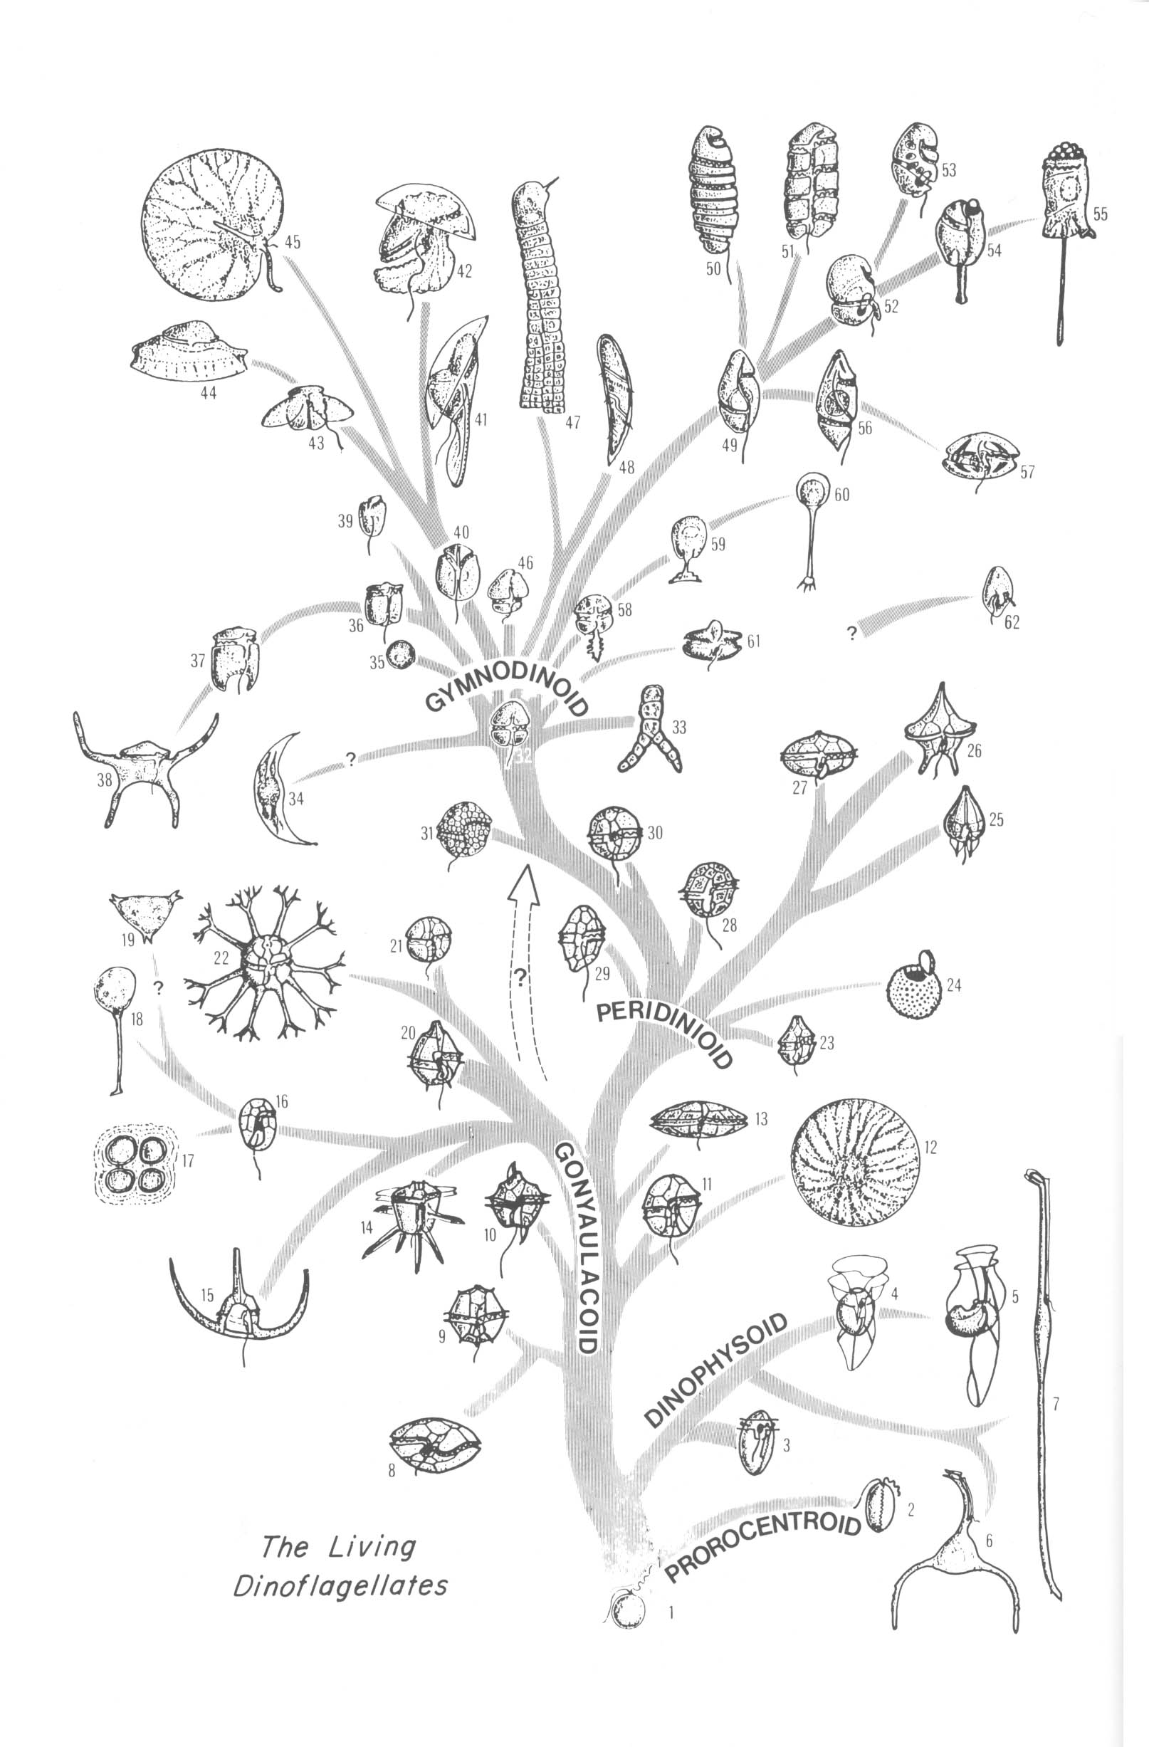
Figure 1. In this tree the ancestral dinoflagellate is assumed to have been desmokont, resembling present-day desmomonads. A case can also be made for the group to have arisen from a gymnodinoid form, possibly like Oxyrrhis, in which case the arrangement would be somewhat the inverse of the present arrangement. Only a quarter of the living genera are shown in the tree.
1, Desmomonad ancestor, resembling Desmomastix or Pleromonas. 2, Prorocentrum. 3, Dinophysis. 4, Ornithocercus. 5, Parahistioneis, Histioneis. 6, Triposolenia. 7, Amphisolenia. 8, Gambierdiscus (also Ostreopsis, Coolia). 9, Triadinium (= Heteraulacus). 10, Pyrodinium. 11, Protogonyaulax (also AlexandriumjGessnerium, Fragilidium). 12, Pyrocystis. 13, Pyro-phacus. 14, Ceratocorys. 15, Ceratium. 16, Hemidinium (possibly also Crypthecodinium). 17, Gloeodinium. 18, Stylodinium. 19, Tetradinium and other Phytodinialians. 20, Gonyaulax. 21, Palaeophalacroma. 22, Cladopyxis. 23, Scrippsiella. 24, Thoracosphaera. 25, Podolampas (and Blepharocysta).26, Protoperidinium. 27, Diplopsalopsis, Dissodium, Oblea and other diplopsaloids. 28, Peridinium. 29, Heterocapsa (= Cachonina). 30, Glenodinium. 31, Woloszynskia. 32, Gymnodinium. 33, Dinothrix, Dinoclonium. 34, Dissodinium. 35, Symbio-dinium, Zooxanthella. 36, 37, Amphidinium e.p. 38, Brachydinium. 39, 40, Amphidinium e.p. 41, Kofoidinium. 42, Pomatodinium. 43, Cymbodinium. 44, Craspedotella. 45, Noctiluca. 46, Katodinium. 41, Haplozoon. 48, Blastodinium. 49, Gyrodinium. 50, Cochlodinium. 51, Polykrikos. 52, Proterythropsis (and Warnowia). 53, Nematodinium. 54, Erythropsidinium. 55, Greuetodinium (= Leucopsis). 56, Plectodinium. 51, Actiniscus. 58, Protoodinium. 59, Oodinium. 60, Chytriodinium. 61, Ptychodiscus. 62, Oxyrrhis. From Taylor (1987).
------------------------
Among the microalgae, the dinoflagellates comprise the largest number of toxic species. Most species belong in the orders Prorocentrales, Dinophysiales, Gonyaulacales, and Gymnodiniales, but a few members of the Peridiniales may also be toxic. Thus, Heterocapsa circularisquama Horiguchi 1995 is reported to cause mass mortality in Japanese shellfish aquaculture, but is apparently not harmful to fish or other marine fauna (Horiguchi 1995, Oda et al. 2001). It has been reported so far only from Japan, but may be a potential thread to shellfish aquaculture in East Asia. Other potentially toxic peridinioids are Proroperidinium crassipes which may produce the toxin(s) causing azaspirazid shellfish poisoning (AZP) (Griddle 2002, cited in Landsberg 2002), and there is a single report that the fresh water species Peridinium polonicum may be toxic (Hashimoto 1968). Species of Pfiesteria has been reported to be extremely toxic to fish, but this has subsequently been questioned by other authors.

1.4. Identification of dinoflagellates
Unarmoured species (Gymnodiniales) and species of Prorocentrales and Dinophysiales are identified by a combination of various morphological features, see the respective sections. In the Peridiniales and Gonyaulacales, tabulation and plate pattern are important for species identification. For identification purposes, the artificial system introduced by Kofoid (1909, 1911) and modified by Balech (1980) is generally used. This system recognizes plate series based on their position on the cell. Tabulation refers to the number of plates in the specific series of plates, while plate pattern refers to the specific morphology of particular plates, see The Kofoidian system.
While the Kofoidian system is artificial and does not attempt to recognize plate homologies between genera and species, other systems e.g. the Taylor-Evitt system, attempt to reflect such plate homologies, see also Fensome et al. (1993).

For general identification of dinoflagellates, the reader is referred to Balech (1988), Schiller (1933, 1937), Steidinger (1997) and Taylor (1976).

1.5. References

Balech, E. 1980. On thecal morphology of dinoflagellates with species emphasis on cingular and sulcal plates. – Anales del Centro de Ciencias del Mar y Limnologia Universidad Nacional Autonoma de Mexico 7: 55-64.
Balech, E. 1988. Los Dinoflagelados del Atlántico Sudoccidental. Publ. Espec. Inst. Esp. Oceanogr. 1, 310 p.
Fensome, R.A., Taylor, F.J.R., Norris, G., Sarjeant, W.A.S., Wharton, D.I. & Williams, G.I. 1993. - Micropaleontology, Special Publication Number 7, 351 pp.
Hashimoto, Y. 1968. Glenodinine, an ichthyotoxic substance produced by a dinoflagellate, Peridinium polonicum. – Nippon Suisan Gakkaishi 34: 528-534.
Horiguchi T. 1995. Heterocapsa circularisquama sp. nov. (Peridiniales, Dinophyceae); a new marine dinoflagellate causing mass mortality of bivalves in Japan. – Phycol. Res. 43: 129-136.
Kofoid, C.A. 1909. On Peridinium steinii Jørgensen, with a note on nomenclature of the skeleton of Peridinidae. – Archiv für Protistenkunde 16:25-47.
Kofoid, C.A. 1911. On the skeletal morphology of Gonyaulax catenata. – Univ. of California Publications in Zoology 8:287-294.
Landsberg, J. H. 2002. The effects of harmful algal blooms on aquatic organisms. – Reviews in Fisheries Science 102: 113-390.
Larsen, J. & Sournia, A. 1991. The diversity of heterotrophic dinoflagellates. - In: Patterson, D.J. & Larsen, J. (eds), The biology of free-living heterotrophic flagellates. Systematic Association, Special Volume 45, Clarendon Press, Oxford, 313-332.
Oda, T., Sato, Y., Kim, D., Muramatsu, T., Matsuyama, Y. & Honjo, T. 2001. Hemolytic activity of Heterocapsa circularisquama (Dinophyceae) and its possible involvement in shellfish toxicity. – J. Phycol. 37: 50.
Schiller, J. 1933. Dinoflagellatae (Peridineae). - In: Rabenhorst, L. (ed.). Kryptogamen Flora von Deutschland, Österreichund der Schweiz 10(3). I Teil. Akademische Verlags-gesellschaft. Leipzig.617 pp.
Schiller, J. 1937. Dinoflagellatae (Peridineae). - In: Rabenhorst, L. (ed). Kryptogamen Flora of Deutschland, Österreichund der Schweiz 10(3). II Teil.Akademische Verlags-gesellschaft. Leipzig. 590 pp.
Sournia, A. 1986 Atlas du phytoplankton marin. Volume 1: Introduction, Cyanophydées, Dictyochophydées, Dinophycées et Raphidophycées. – Editions du Centre National de la Recherche Scientifique, Paris, 219 pp.
Spector, D.L. (ed.) 1984. Dinoflagellates. – Academic Press, Orlando, 545 pp.
Steidinger, K.A. 1997. Dinoflagellates. – In: Tomas, C.R. (ed.), Identifying marine phytoplankton, Academic Press, San Diego, pp.387-584.
Taylor, F.J.R. (ed.) 1987. The biology of dinoflagellates. – Blackwell, Oxford, 705 pp.
Taylor, F.J.R. 1976. Dinoflagellates from the International Indian Ocean Expedition. A report of material collected by the R.V. “Anton Bruun” 1963-64. – Bibliotheca Botanica, Stuttgart, 234 pp + 46plates.

1.6. Glossary

Dinoflagellates
English | Español | Portugês
Acrobase | Acrobase | Acrobase
Amphiesma | Anfiesma | Amfiesma
Antapical plates | Placas antapicales | Placas anteapicais
Anterior intercalary plates (a) | Placas intercalares anteriores | Placas intercalares anteriores
Apical furrow | Surco apical | Sulco apical
Apical groove | Surco apical | Sulco apical
Apical plates | Placas apicales | Placas apicais
Apical pore complex (APC) | Complejo del poro apical | Complexo do poro apical
Apical pore | Poro apical | Poro apical
Apical pore plate (Po) | Placa del poro apical | Placa do poro apical
Areolate | Areolado | Areolado
Armoured | Tecado | Tecado, com parede celular
Archeopyle | Arqueopilo | Arqueópilo
Attachment pore | Poro de unión | Poro de união
Azaspirazid shellfish poisoning | Envenenamiento de moluscos por azaspirazid | Envenenamento com azaspirazid através de moluscos
Canal plate | Placa de la canaleta | Placa do canal
Chain | Cadena | Cadeia
Ciguatera | Ciguatera | Ciguatera
Cingular plates | Placas cingulares | Placas do cíngulo
Cingulum | Cingulum, Cíngulo, Surco transversal | Cíngulo, sulco transversal
Cingulum displacement | Desplazamiento cingular | Deslocamento do cíngulo
Cingulum turns | Vueltas/Giros del cíngulo | Giros do cíngulo
Collar | Collar, Cuello | Colar, colo
Comma-shaped | En forma de coma | Em forma de vírgula
Cortex | Corteza | Córtex
Cyst | Quiste | Cisto
Desmokont | Desmoconta | Desmoconto
Desmomonads | Desmomonadas | Desmomonadas
Diarrhetic Shellfish Poisoning (DSP) | Envenenamiento diarreico por moluscos | Envenenamento diarréico através de moluscos
Dinocarion | Dinocarion | Dinocario
Dinokont | Dinoconta | Dinoconte
Epicone | Epicono | Epicone
Episome | Episoma | Epissoma
Eyespot | Estigma | Estigma
Flagellar pore | Poro flagelar | Poro do flagelo
Flange | Reborde | Beira
Girdle | Cingulum, Cíngulo | Cíngulo
Girdle list | Aleta cingular | Aba
Gonyaulacoid | Goniaulacoide | Goniaulacóide
Gymnodinioid | Gimnodinioide | Gimnodinióide
Heterotrophic | Heterotrófico | Heterotrófico
Holozoic | Holozoico | Holozóico
Horn | Cuerno | Chifre
Hypnozygote | Hipnocigota | Hipnozigoto
Hypocone | Hipocono | Hipocone
Hiposome | Hiposoma | Hipossoma
Hypotheca | Hipoteca | Hipoteca
Intercalary plate | Placa intercalar | Placa intercalar
List | Aleta | Aba
Megacytic growth zone | Zona megacítica de crecimiento | Zona de crescimento megacítico
Mixotrophic | Mixotrófico | Mixotrófico
Morphospecies | Morfoespecie, Especie morfológica | Espécie morfológica
Naked | “Desnudo”, Atecado | Atecado, desnudo
Neck | Cuello | Colo
Nematocyst | Nematocisto | Nematocisto
Neurotoxic Shellfish Poisoning | Envenenamiento neurotóxico por moluscos | Envenenamento neurotóxico através de moluscos
Ocellus | Ocelo | Ocelo
Paralytic Shellfish Poisoning | Envenenamiento paralizante por moluscos | Envenenamento paralisante através de moluscos
Peduncle | Pedúnculo | Pedúnculo
Pellicle | Película | Película
Peridinioid | Peridinioide | Peridinióide
Phototrophic | Fototrófico | Fototrófico
Planozygote | Planocigota | Planozigoto
Platelet | Plaquita | Placa pequena
Plates | Placas | Placas
Plate pattern | Patrón de placas, Patrón tecal | Padrão das placas
Pore | Poro | Poro
Post-cingular plates | Placas postcingulares | Placas pós-cingulares
Posterior intercalary plate (p) | Placa intercalar posterior | Placa intercalar posterior
Pre-apical plate | Placa preapical | Placa pré-apical
Pre-cingular plates | Placas precingulares | Placas pré-cingulares
Pusule | Púsula | Pusulo
Reticulate | Reticulado | Em forma de teia, reticulado
Rib | Costilla | Costela
Spheroplast | Esferoplasto | Esferoplasto
Spine | Espina | Espinho
Spirolide Shellfish Poisoning | Envenenamiento de moluscos por spirolide | Envenenamento spirolide através de moluscos
Squashed | Aplastado | Esmagado
Striae | Estrías | Estrias
Sulcal plates | Placas sulcales | Placas do sulco
Sulcus | Sulcus, Surco longitudinal | Sulco
Suture | Sutura | Sutura
Tabulation | Tabulación | Tabulação
Theca | Teca | Teca, parede celular
Thecal vesicle | Vesícula tecal | Vesícula da teca
Thecate | Tecado, “Vestido” | Tecado, com parede celular
Transitional plate | Placa transicional | Placa de transição
Transverse groove | Surco transversal, Cíngulo, Cingulum | Sulco transversal
Trichocyst | Tricocisto | Tricocisto
Unarmoured | “Desnudo”, Atecado | Desnudo, atecado, sem parede rígida
Valve | Valva | Valva
Vegetative cell | Célula vegetativa | Célula vegetativa
Ventral | Ventral | Ventral
Ventral pore | Poro ventral | Poro ventral
Ventral ridge | Cresta ventral | Crista ventral
Vermiculate | Vermiculado | Vermiculado
Wall | Pared celular | Parede celular

