The Kofoidian Tabulation

Introduction
Many species of peridinioid and gonyaulacoid dinoflagellates can be identified to genus or even species without a detailed examination of the plate pattern. Thus species of e.g. Protoperidinium and Ceratium can usually be referred to genus immediately, and with some experience many species are also easily identified, see e.g. Steidinger (1997).

In other cases it is necessary to discern the plate pattern and examine this in great detail. The genera and species are identified by a combination of characters, e.g. gross morphology (size, shape, spines, horns etc.) and in particular the number and arrangement of plates, see also Steidinger (1997, Table 1).

Example 1, Peridinioid tabulation
The schematic drawings (Fig. 1) and the photographs (Figs 2-6, and interpretive drawings, Figs 7-9) show a peridinioid dinoflagellate with indication of the terminology used to describe the various morphological features including the plate pattern.
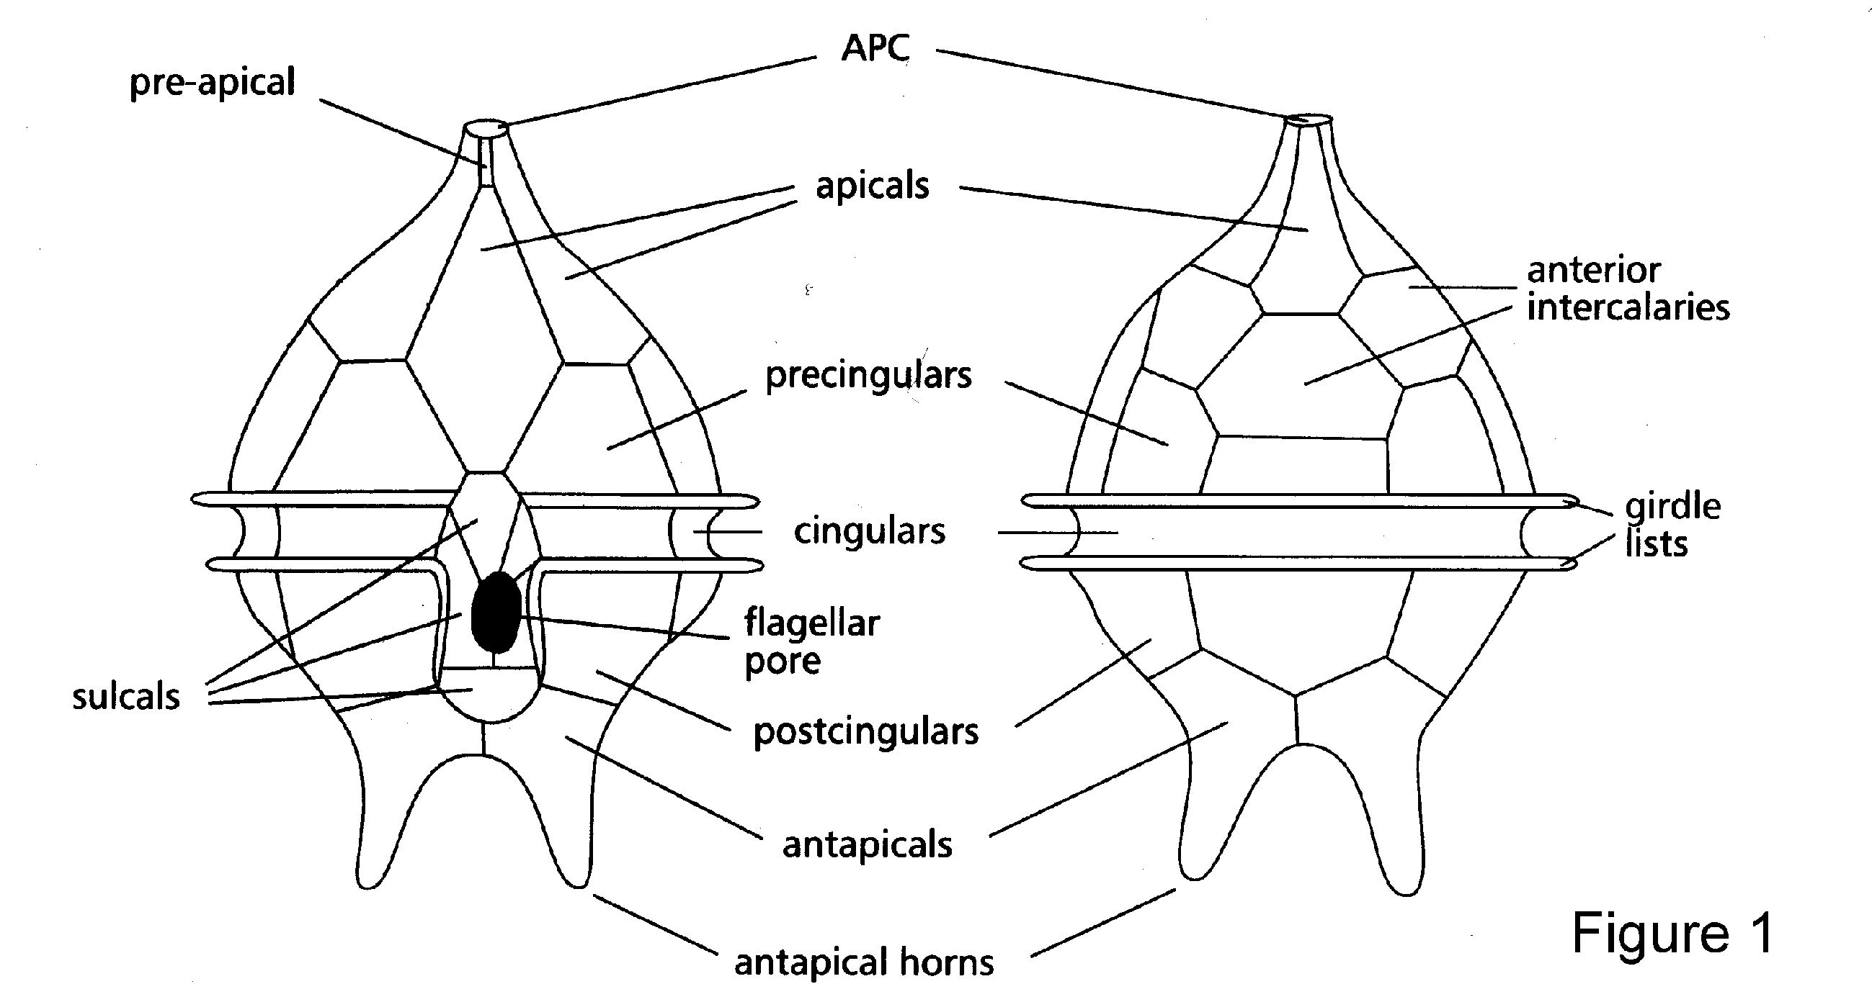

Fig.1. When examining a peridinioid or gonyaulacoid dinoflagellate it is very important to recognize the orientation of the cell, viz. ventral (defined as the side where the cingulum and sulcus meets), dorsal, left, and right which are all defined relative to the ventral side.

The thecal plates are named as follows (short notation is given in brackets):
Apical pore complex (APC): Many species of armoured dinoflagellates have an apical pore plate with an apical pore, which may be rounded-oval or slit-like. In some species an attachment pore is also present.
Pre-apical (X-plate): This tiny plate is found only in the Peridiniales and never in the Gonyaula-cales (see below). Sometimes it is also called the ventral apical plate, canal plate, or x plate. This plate is interpreted as part of the APC by Steidinger (1997) (see also Fig. 7).
Apical plates (‘): The plates that surround and touch the apex or APC when present. In some species, the 1’plate is dislocated and does not reach the apex.
Anterior intercalary plates (a): The epithecal plates located between the apical plates and the pre-cingular plates.
Pre-cingular plates (‘’): The epithecal plates lying adjacent to the cingulum.
Cingular plates (c): The series of narrow plates forming the cingulum.
Sulcal plates (s): The (often tiny) plates forming the sulcus. In some genera, e.g. Alexandrium, sulcal plates - anterior sulcal plate (sa) and posterior sulcal plate (sp) - are important for the differentiation of species.
Post-cingular plates (‘’’): The hypothecal plates lying adjacent to the cingulum.
Antapical plates (‘’’’): Plates that connect to sulcul plates but never to the cingulum.
Posterior intercalary plates (p): Plates that connect neither to the sulcus nor to the cingulum (not illustrated).
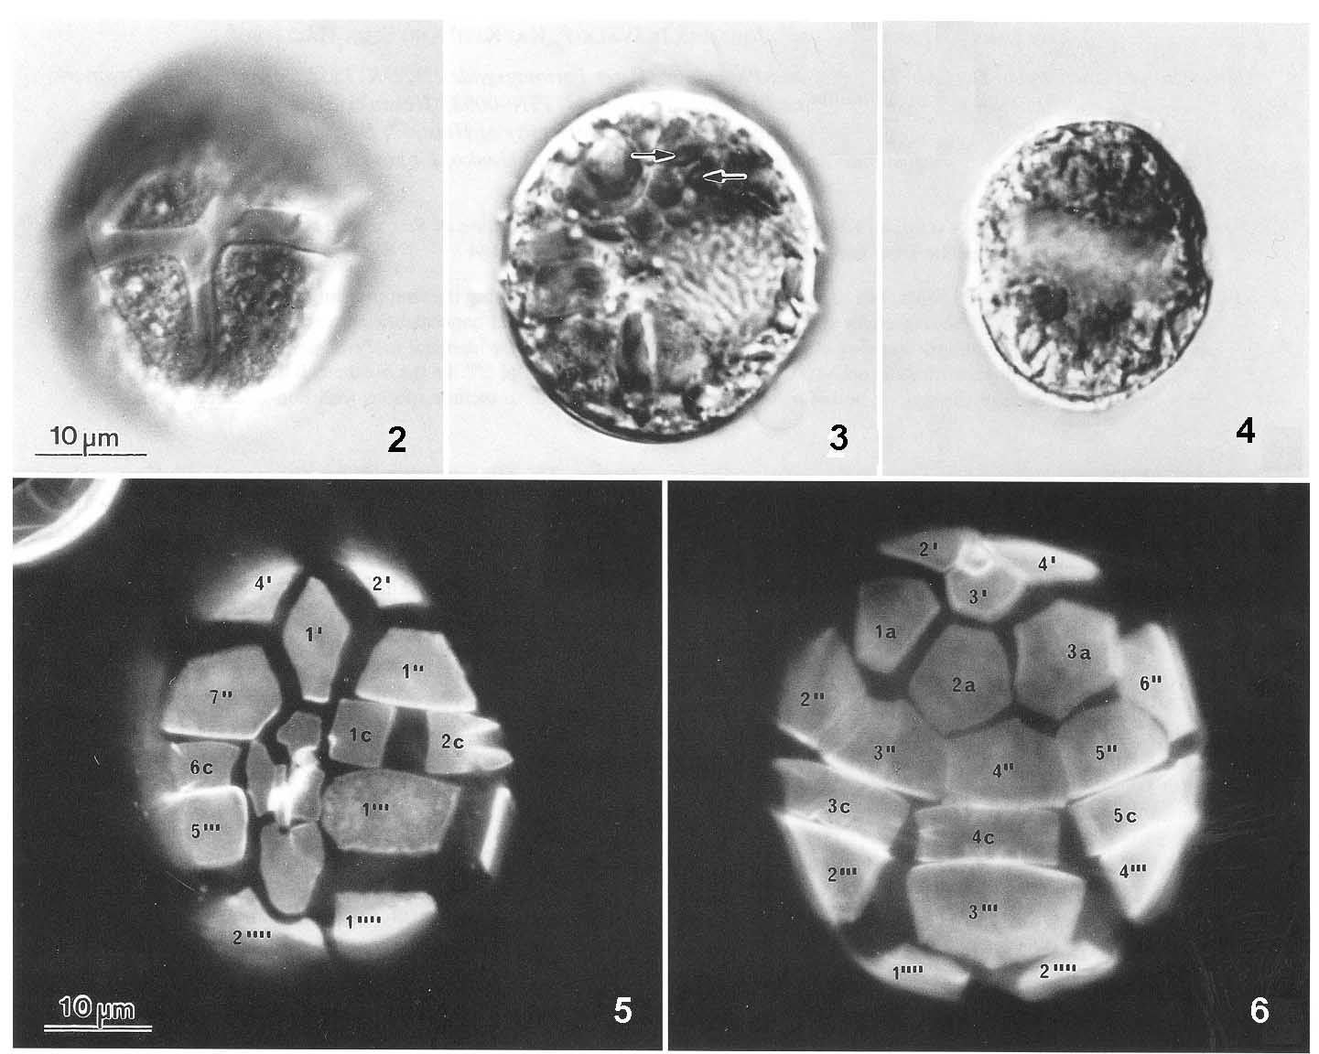
Example 1. Peridinoid tabulation. Figs 2-4. A peridinioid dinoflagellate seen in ventral view, different focal levels, LM, interference contrast; Fig.5. The same species in ventral view, and Fig.6, dorsal view; both LM, epi-fluorescence.

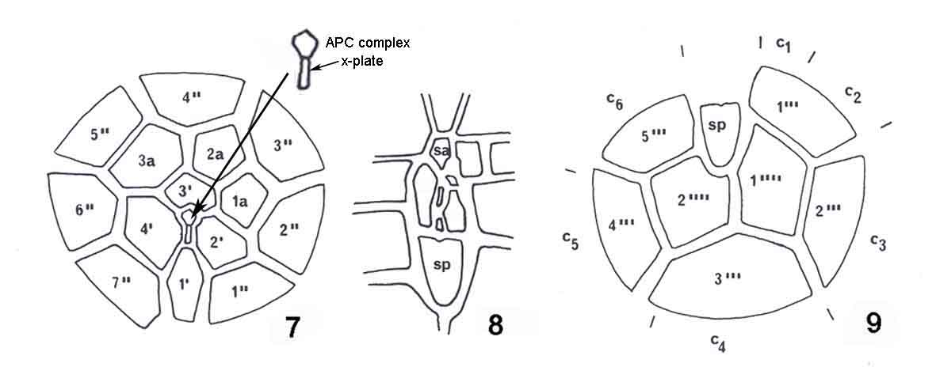
Figs 7-9. Drawings of the cells shown in Figs 5-6. Fig. 7, the epitheca in apical view; Fig. 8. the sulcal plates; Fig. 9, the hypotheca in antapical view. In short notation the plate pattern is as follows: APC, 4’, 3a, 7’’, 6c, 5’’’, 0p, 2’’’’.

The plates in the different series (see Figs 5-9) are given numbers or letters with the ventral-most plate number 1 and the following plates numbered in the counter-clockwise direction in apical view (Fig. 7). This is also the case for the plates on the hypotheca, but as this is most conveniently observed and illustrated in antapical view, the orientation shifts which means, that in antapical view, the hypothecal plates are numbered in the clockwise direction (compare Figs 9 and 5-6).

Example 2, Gonyaulacoid tabulation

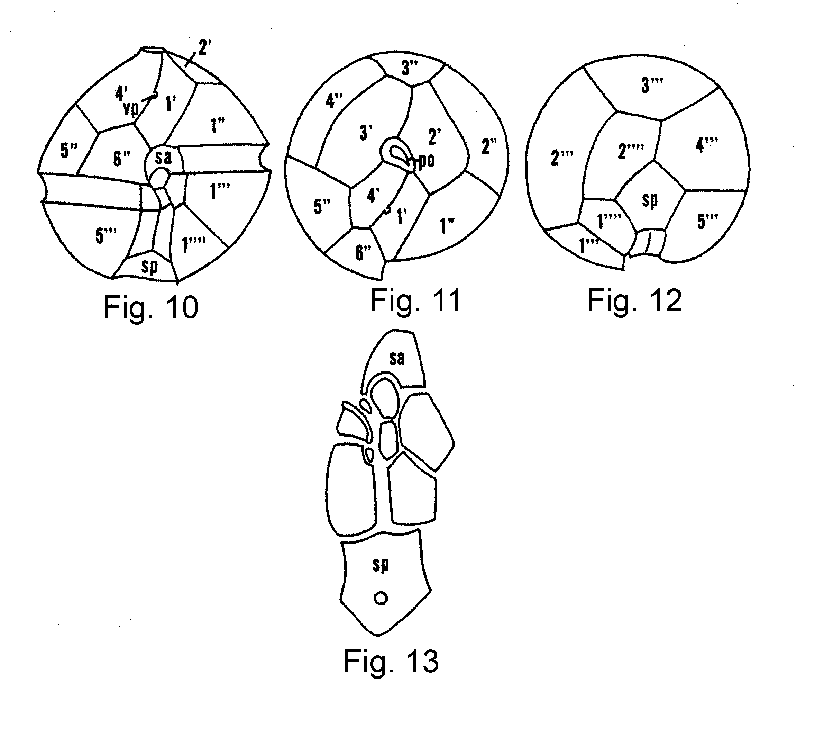
Figs.10-13. The schematic drawings show a gonyaulacoid dinoflagellate with the plates indicated in short notation. Fig. 10, a cell in ventral view; Fig. 11, apical view; Fig.12, antapical view; Fig. 13, the sulcal plates.

Peridinioid versus gonyaulacoid tabulation

Some of the main differences between the peridinioid and gonyaulacoid dinoflagellates are shown in Figs 14-19.

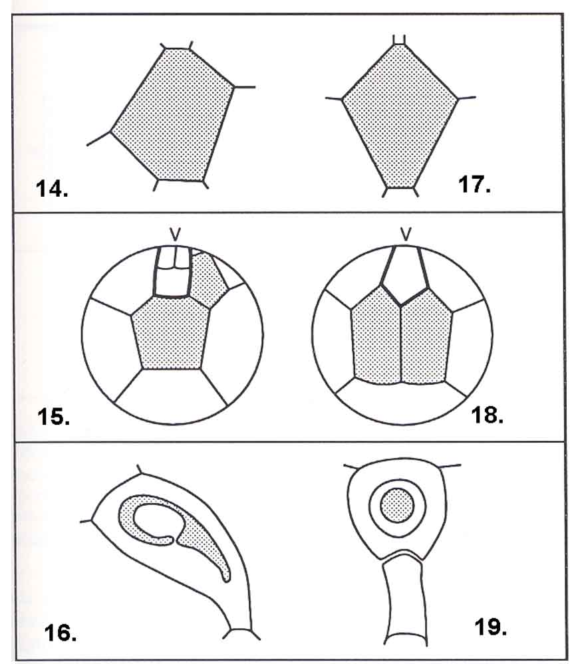

Figs14-19. In the gonyaulacoid dinoflagellates the plate arrangement is asymmetrical (Fig. 14, the 1’ plate; Fig. 15, the antapical plates), and a pre-apical plate is never present (Fig. 16).
Figs 17-19. The peridinioid dinoflagellates are more or less symmetrical around the longitudinal axis (Fig. 17, the 1’ plate; Fig. 18, the antapical plates), and a pre-apical or x-plate may be present (Fig. 19).

There are further differences with regard to the plate arrangement in the sulcal region (after Fensome et al. 1993).

