Module II

Terminology of Pseudo-nitzschia

When measuring width of the valve of Pseudo-nitzschia it is important that the cell is seen in valve view, not in girdle view.

See important morphological characters on Figs 1-4.

Fig. 1 Fig. 2
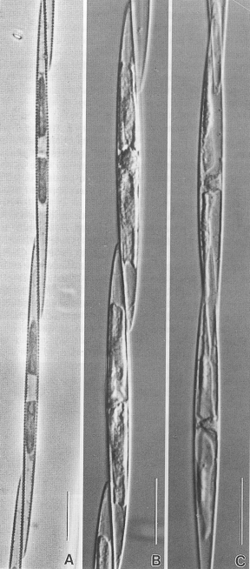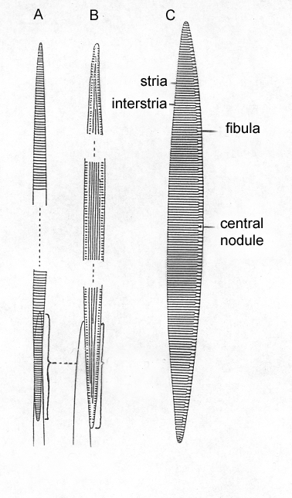

Fig. 1. Colony in girdle view (A, B) and valve view (C) view.
Fig. 2. Colony in valve view (A), girdle view (B) and valve (from Hasle & Syvertsen 1997).

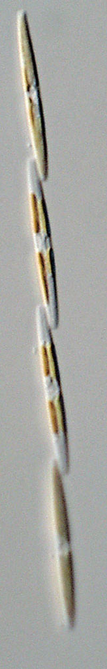

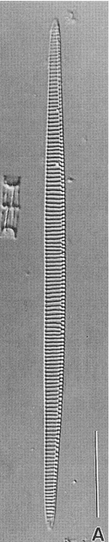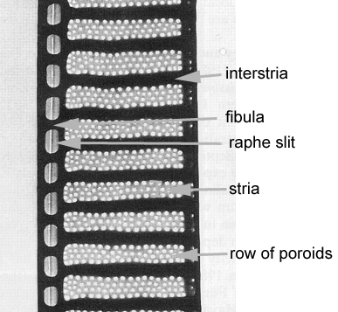

Fig. 3. Colony, valve and part of valve.

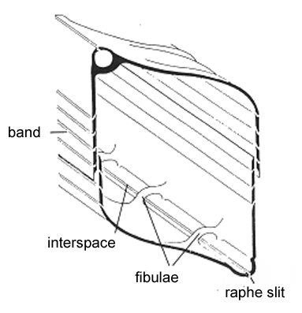

Fig. 4. Section of Pseudo-nitzschia frustule.

Terminology of Chaetoceros

Line drawing scanned from Hasle & Syvertsen (1997).

Chain of cells in girdle view.
aperture
intercalary setae (inner setae)
point of fusion
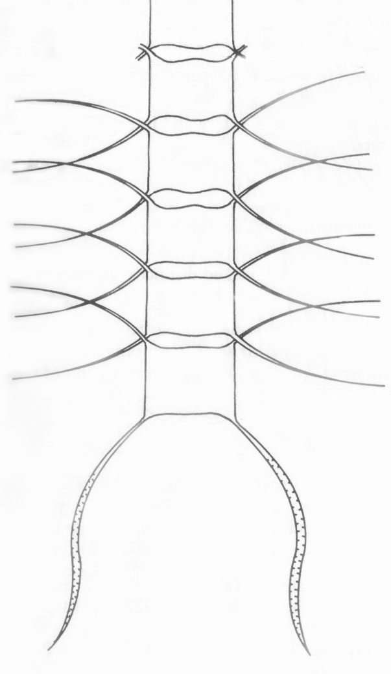
terminal setae

