Module II

Diatom reproduction

Vegetative reproduction causes a reduction in cell size in most species of diatoms. Inside the dividing cell two new valves are formed, which both become hypothecal valves of the daughter cells, while the two valves of the parental cell become the epithecal valves. As a result of this, one of the new-formed daughter cells is smaller than the parental cell (Fig. 1). After a number of successive divisions the cells will reach a critical minimal size where mitosis can no longer take place, and this induces sexual reproduction, which restores the maximum size of the diatom cell (Figs 2-3). Sexual reproduction is different in the pennate and centric diatoms. The centric diatoms are oogamous and the spermatozoids have a single flagellum (Fig. 2), while the pennate diatoms are isogamous, or rarely anisogamous, with non-flagellated gametes (Fig. 3). In both groups, only the sexual stages are haploid, and therefore the life cycle is diplontic.
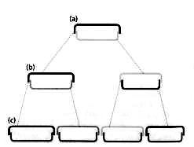
Figure 1. Diagrammatic view of three generations of a diatom, illustrating reduction in the mean cell size as the population increases through time. From Graham & Wilcox (2000).

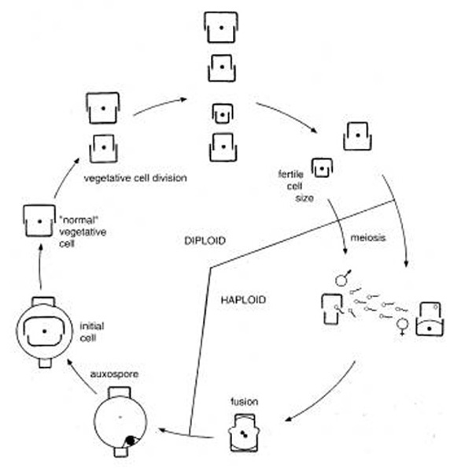 | Figure 2. Sexual reproduction of a centric diatom (oogamy). ✓ Zygote, ● nucleus; o pycnotic nucleus. From Hasle & Syvertsen (1997).
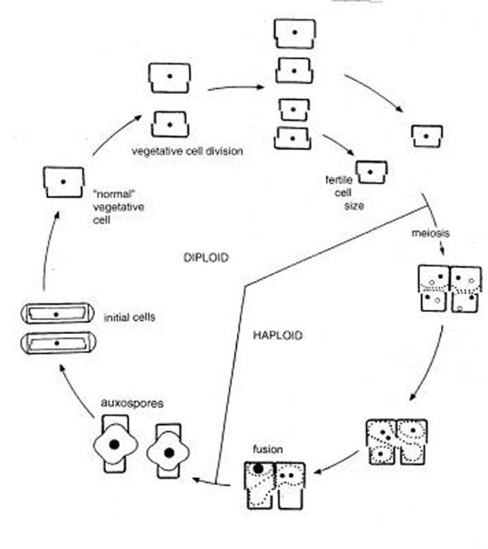 | Figure 3. Sexual reproduction of a pennate diatom (morphological isogamy, physiological anisogamy), legends as in figure 2. From Hasle & Syvertsen (1997).

