Module II

Diatom frustule

The diatom frustule can be divided into two thecae: the epi(upper)-theca and the hypo (lower)-theca (Fig. 1). Each theca is composed of a valve and a cingulum. The cingulum of the upper and the lower theca are called the epi-cingulum and the hypo-cingulum, respectively. The entire part of the frustule between the two valves is called the girdle. Each cingulum comprises a number of girdle bands or copulae. The structure of the bands may vary within a cingulum or all bands may appear more or less similar. The girdle bands may either be open or closed (Fig. 2).
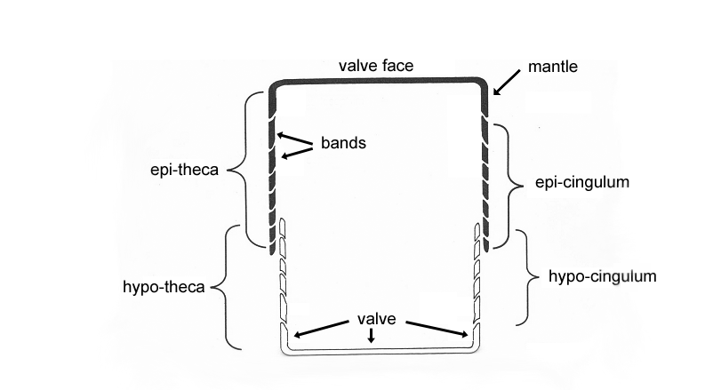
Fig. 1. Cross section of a diatom frustule (redrawn after Hasle & Syvertsen 1997)

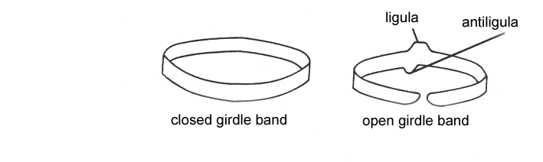

Fig. 2. Girdle bands (redrawn after Hasle & Syvertsen 1997).

Pennate diatoms can be divided into two morphological groups, one group comprising taxa with a raphe, the other group including the taxa without a raphe. A raphe is a longitudinal slit in the valve. The length, the position and the structure of the raphe are important taxonomic characters. The raphe may be a simple raphe or a canal raphe (Fig. 3). In the latter, silica bridges, called fibulae, unite the two sides of the raphe slit. A sort of a canal is thereby formed beneath the fibulae along the interior of the raphe and this canal is partly separated from the rest of the cell lumen. The space between the two fibulae is called the interspace. A canal raphe is e.g. known from Pseudo-nitzschia and Nitzschia species.

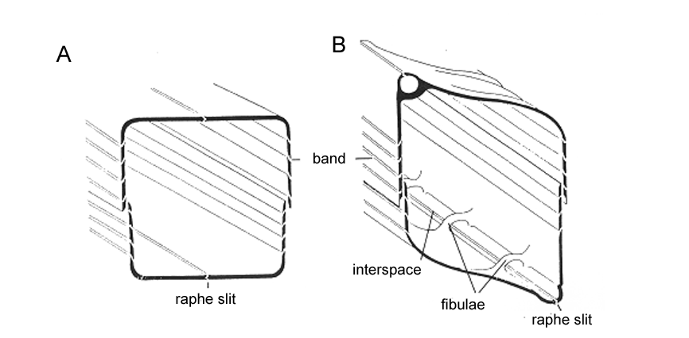
Fig. 3. Transverse sections of diatom frustules showing the two kinds of raphe systems. A. Simple raphe. B. Canal raphe (redrawn after Hasle & Syvertsen 1997).

In some genera, the canal raphe may be raised on a keel (Fig. 4). This is e.g. found in some Nitzschia species.

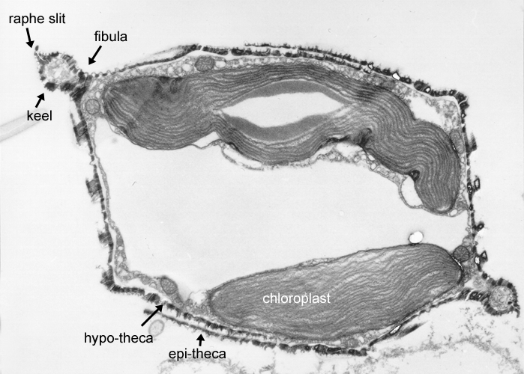

Fig. 4. Transverse section through a Nitzschia navis-varingica cell. Note that the raphe is raised on a keel.

