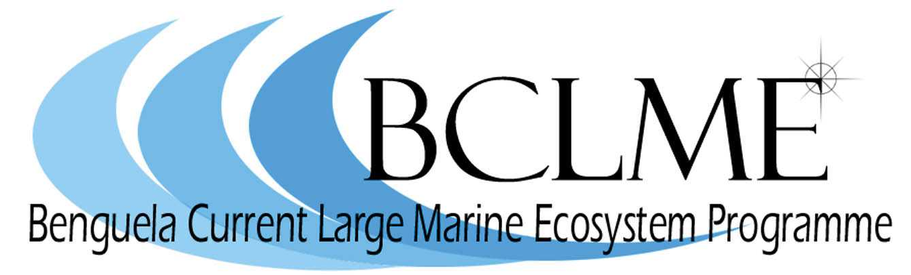
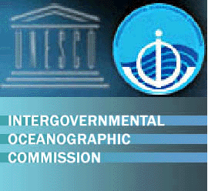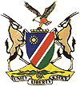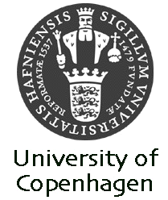

Regional Training Course on Harmful Algae

Swakopmund, Namibia, 22 January – 2 February 2007

PRELIMINARY PROGRAMME

 | Morning 9-12 | Afternoon 14-17
Monday,  22 January | Arrival of participants
Tuesday,  23 January | Welcome address.  Lecture: Biology of harmful algae  Introduction by the participants, 15 min. | Introduction by the participants, 15 min., continued
Wednesday,  24 January | Lecture and microscope demonstration: harmful haptophytes;  Lecture and microscope demonstration: harmful raphidophytes | Lecture and microscope demon-stration: harmful raphidophytes, continued;  Lecture and demonstration of culture work
Thursday,  25 January | Culture work, exercises | Lecture and microscope demonstration: unarmoured dinoflagellates
Friday,  26 January | Lecture and microscope demonstration: Dinophysis | Lecture and microscope demonstration: Prorocentrum
Saturday,  27 January | Lecture and microscope demonstra-tion: Pyrodinium and benthic dino-flagellates other than Prorocentrum | Free
Sunday,  28 January | Excursion
Monday,  29 January | Lecture and microscope demonstration: Alexandrium | Lecture and microscope demonstration: Pseudo-nitzschia
Tuesday,  30 January | Lecture: Sampling techniques and strategies  Microscopy of own material | Lecture: Summary of counting tech-niques and exercises
Wednesday,  31 January | Lecture: Critical species identification  Microscopy of own material | Discussion of id-guide for the Benguela waters,  Microscopy of own material
Thursday,  1 February | Discussion of id-guide for the Benguela waters, continued  Microscopy of own material | Final discussions of id-guide and future collaboration,  Evaluation and course certificates
Friday,  2 February | Departure

