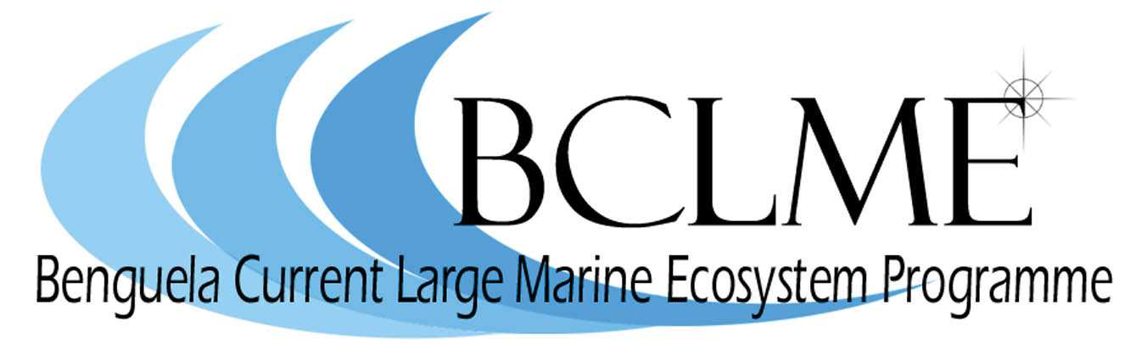

Media Release

The ministers responsible for the management of marine fisheries in Angola, Namibia and South Africa will come together in Windhoek on Friday 20 July, for the First Ministerial Conference of the Benguela Current Commission.
The Benguela Current Commission is the first commission of its kind in the world and lays the groundwork for the three countries to introduce an “ecosystem approach” to managing the Benguela Current Large Marine Ecosystem (BCLME). This means that, instead of managing living and non-living resources at the national level, the countries will work together to tackle problems that affect the marine environment. These problems include pollution, the management of shared fish stocks and the mitigation of the impacts that marine diamond mining and oil and gas production have on the BCLME.

An Interim Agreement establishing the Benguela Current Commission was signed by South Africa and Namibia in August 2006 and by Angola in January 2007.

At Friday’s Ministerial Conference, Dr Abraham Iyambo, Minister of Fisheries and Marine Resources in Namibia, will be joined by his regional counterparts - Salomão Juheto Xirimbimbi, Minister of Fisheries in Angola, and Marthinus van Schalkwyk, Minister of Environmental Affairs and Tourism in South Africa – to discuss the function, role and mandate of the Benguela Current Commission.

The Ministers will also decide on the location and hosting of the Commission’s Secretariat and consider a programme of action to implement the ecosystem approach to managing the BCLME. The appointment of the Executive Secretary, Ecosystem Co-ordinator and support staff will also be discussed, along with a proposed operational plan and budget for the Secretariat.

“The First Ministerial Conference of the Benguela Current Commission will set out the Commission’s work for the next three years,” says Dr Mick O’Toole, head of the BCLME Programme and Acting Executive Secretary of the BCC. “However, the meeting of ministers also sends out a strong signal that the three countries of the Benguela Region are serious about managing their shared resources in a sustainable and integrated way.”
The Benguela Current Commission will ultimately make recommendations to the three countries on research and management issues relating to the sustainable utilisation, conservation and protection of the BCLME. It will be informed by an Ecosystem Advisory Committee which will supply countries with the best available information concerning the implementation of the ecosystem approach to management.

Members of the media are invited to attend the opening ceremony of the Ministerial Conference which will take place in the Omatako Room, Safari Hotel, Windhoek from 10.00 to 10.45 on Friday July 20.

Issued by the Benguela Current Large Marine Ecosystem Programme
17 August 2007

For further information:
Dr Michael O’Toole (Acting Executive Secretary: Benguela Current Commission)
+264 61 24 6948
081 1290830

Claire Attwood (Media Consultant: BCLME Programme)
+ 27 21 788-5453 or +27 83 290 7995

